Backpack Speaker System

ECE4012 Senior Design Project

Section L6B, Team BTDE
SD20P02
Project Advisor, Dr. Robinson

David Rogers - EE - drogers62@gatech.edu - Team Leader
Jack Glennon - EE -jglennon7@gatech.edu
Andrew Vernetti - CompE - avernetti3@gatech.edu - Webmaster
Alex Mathis - EE - amathis37@gatech.edu
Connor Brothers - CompE - cbrothers3@gatech.edu

Submitted

2020 April 29

Executive Summary
The Portable Bluetooth Stereo Backpack Speaker System was designed to be a mobile, durable, and high quality speaker system. The speakers could connect via Bluetooth to any device or be connected physically via a 3.5 mm audio jack as input. The final system would consist of a subwoofer box and two satellite speaker boxes each of which would both contain a woofer and a tweeter. The subwoofer box would house the circuitry for the system: an amplifier, a microcontroller, and a Bluetooth module, as well as the power supply system and the circuit boards to contain each subsystem.
As a result of the COVID-19 pandemic, not all of the above original goals were able to be achieved. Development had just begun on integrating Bluetooth, the amplifier, and the microcontroller when everything came to a screeching halt. Without the ability to purchase new materials, no development was able to begin on the physical containment of the speaker boxes. Additionally the power supply system parts and the high quality speakers were not purchased.
In the end, the working prototype that was developed was the main circuitry behind what would’ve been a great, high-quality speaker system. The microcontroller communicates with the Bluetooth and amplifier modules. The speaker system is able to take in an analog input and amplify it to the output which would be connected to the external speakers. Because no speaker boxes were constructed or speakers were bought, no analysis can be made of the portability of the system. Additionally, no analysis can be made on the efficiency relative to the power/battery supply as no power supply exists.

Table of Contents

Executive Summary 1
Table of Contents 3
1. Introduction 4
1.1 Objective 4
1.2 Motivation 5
1.3 Background 6
2. Project Description and Goals 7
3. Technical Specifications & Verification 8
4. Design Approach and Details 11
4.1 Design Approach 12
4.2 Codes and Standards 15
4.3 Constraints, Alternatives, and Tradeoffs 15
5. Final Project Demonstration 17
6. Conclusion 17
7. Leadership Roles 18
8. References 20
Appendix A: QFD Diagram 22
Appendix B: TAS3251 Amplifier Schematic 23
Appendix C: TAS3251 Amplifier 24

Introduction

The Portable Bluetooth Stereo Backpack Speaker System was planned to be a mobile, durable, and quality speaker system that can connect over Bluetooth to any mobile device. The system was designed to consist of a backpack rig to carry the speakers, a subwoofer, two satellite woofer/tweeter mid-range speakers, and a mobile app to control the equalization and input of the system, Figure 1 depicts the original design for the project. Big Type D Energy was awarded $750 to use for the project, but only $20 was used due to halts in ordering.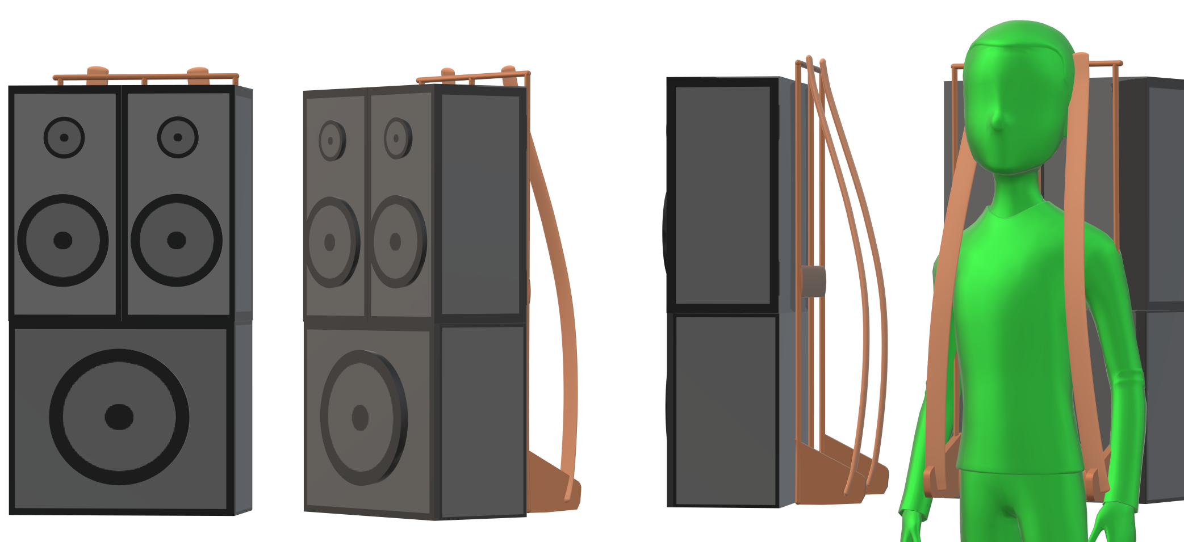
Figure 1. Three dimensional rendering of the backpack speaker.

Objective
The goal of this project was to create a portable backpack system of speakers including a subwoofer to fill the need of a portable, loud, high quality speaker system. The system was designed to have sufficient battery life and a user interface that was easy to use. It was meant to provide decent sound quality and volume, have the equalization controlled through a companion app connected over Bluetooth, and take audio input via Bluetooth, analog RCA, or 3.5mm jack. Additional features could have included the ability to connect to up to 4 aftermarket Bluetooth speakers, RGB lighting that changes based on the volume and frequency of the music being played, and additional equalization settings and other signal processing. See Appendix A for a QFD with further details on customer desires versus engineering requirements.

Motivation
Currently in the speaker market, there are not many portable speaker systems that are easy to carry around except for on a cart. Those that are portable are too small to produce meaningful sound pressure and many have a poor frequency response. An example of a similar style speaker already on the market is the “Soundboks”. The Soundboks is 216 Watts, 34 lbs, and retails for over $900 [1]. It is battery powered and transported via handle, but a backpack attachment is made for it and is sold separately for $129 [2]. In addition to the high cost, the Soundboks does not have tweeters or a dedicated subwoofer which can lead to both poor highs and lows. It is also a single unit making it unable to produce stereo imaging. Our speaker system would be more cost effective, higher power, and have the added bonus of stereo imaging. Another system similar in style is the 1996 Cambridge SoundWorks Model 12. The Model 12 is 40 Watts, 24 lbs and transportable via suitcase [3]. It has 2 speakers and an amplifier that are removed from the suitcase which, when closed, doubles as a subwoofer. While this system does have the capability of imaging, it is unable to fill the need of an outdoor speaker with its small size. Our backpack speaker system was designed to allow the user to have a decently portable and high quality sound source for whatever event they would need it. It was also designed to be user-friendly unlike the Model 12 that requires an amplifier to be wired and unwired with each use. The backpack speaker system design seeks to fill a hole that the team identified in the speaker market for complete systems that are portable enough to be carried around and used on battery power but provide high enough quality to be able to replace normal high-end speaker systems.

Background
Generally, speaker systems contain 2 full-range speakers and a subwoofer. The purpose for the two mid-range speakers is to create stereo sound from two different sources of left and right channels which is how almost all music is recorded. Each of these speakers will typically consist of two different speaker cones. The first is the woofer which is the main workhorse of the mid-range frequencies. The second is the tweeter which provides the best frequency response at higher frequencies. The subwoofer is responsible for the booming bass of the lower frequency notes. Typically, these speakers would all connect to an external amplifier, where the input from a different source would come in, be equalized and boosted, then be filtered to the different output speakers depending on frequency range. In this system, it was instead proposed to have an internal amplification system that was housed inside of the subwoofer box. Many powered subwoofers have amplifiers in their boxes already making this a feasible goal [4]. The subwoofer box was designed to take audio input via a 3.5mm line-in or via Bluetooth. This allows the reduction in complexity of connections to two speaker cables, one for the left speaker and one for the right with each containing individual wires for the tweeter and woofer signals. This system would be fully self-contained and would be able to be used as a standalone system with minimal complexity of parts and subsystems.

Project Description and Goals
The team’s design was to implement a portable speaker system consisting of three main components: a mobile app, mid-range speakers, and a subwoofer. The mobile app would allow, via Bluetooth connection, the user to control the source input to the speakers, as well as what equalization settings were desired. Most of the focus of the project was spent on the class D amplifier which turned out to be quite the challenge to debug and implement properly. One of the biggest goals was worked on was getting sound to be produced from a small testing speaker.
The original project goals included the following:
General
- Speaker system should be lightweight enough to reasonably be carried on a backpack frame
- Total cost less than $500
- System should be weather resistant and durable to withstand frequent unloading and carrying
- Contain own amplification system with digital crossovers
Mobile App
- Control source input via Bluetooth to the speakers
- Choose different equalization settings/digital signal processing functions to run on the microcontroller inside the speaker system
- Send commands to control the volume of the speaker system
Speakers
- Be able to produce high quality sound with low frequency response
- Can be powered for a reasonable time from a battery pack
Some of the original goals were not accomplished due to the COVID-19 outbreak leaving group members unable to meet in person or access campus. These included assembling of the actual speaker system itself and working towards portable power for it. Communication was able to be established between the MSP432 and the Bluetooth module, however progress was not made as far as to produce sound via Bluetooth connectivity.

Technical Specifications & Verification
As group members were unable to meet in person, the scope of the project was adjusted to accommodate the limited access to the project as well as the inability to order new parts. In order to prove the concept of the original project, it was decided that the audio system that would have been inside the backpack speaker could still be built or at least prove that the original project could have been built.
The original specifications are listed in Table 1 and Table 2. The overall project has been severely limited with most of the original specifications being non-applicable such as final power specifications, enclosure weight and dimensions, and acoustic specifications. The final power specifications were not able to be assessed due to the inability to build the entire system. The power consumption of a single amplifier with an MBED and the Bluetooth module was measured to be 1.68 Watts with the amplifier out of standby. With the amplifier’s output stage off, the measured power drops to 0.36 Watts.

Feature | Specification
Maximum frequency response ripple | 0.5 dB
Speaker/box combo alignment | Butterworth (B2 or B4)
Power output | 200 W
Driver sensitivity (at 2.83 V) | >90 dB
Frequency range | 20-20,000 Hz
Table 1. Acoustic Specifications

Feature | Specification
Total weight | <40 lbs
Processing & Bluetooth power | .5 W
LED lighting power | 1.5 W
Processing delay | <100 ms
Setup time | <1 min
Startup time | <5s
Maximum dimensions | 2’ x 1.5’ x 3.5’
Cable length | 6’
Auxiliary simultaneous bluetooth devices | 1-4
Power supply voltage | 24 V
Analog input | 2 RCA, 1 3.5 mm
Battery life @ 200 W | 1 hrs
Table 2. General Specifications
The final specifications of the project were scoped down to just consisting of the audio system of the backpack speaker. This included: auxiliary analog input conversion to digital for signal processing within amp, Bluetooth communication with digital I2S out, amplifier with digital I2S input, and matched output filters to support 4 Ohm speaker loads. The revised specifications are listed below in Table 3.
Table 3. Revised specifications for just the system’s electronics.
Processing and Bluetooth power | <.5 W
Processing delay | <100 ms
Startup time | <5s
Auxiliary simultaneous Bluetooth devices | 1-4
Power supply voltage | 24 V

First, on the communication side of the system, the main audio communication to the amplifier needed to be PCM over I2S to support high quality audio signals which was accomplished but limited to a single amplifier due to lack of additional supplies. The original plan was to utilize a high quality ADC, the TLV320ADC6140, to convert the auxiliary analog input to I2S, however, due to power supply instability causing voltage spikes on the 3.3V line, the ADC stopped working correctly and the decision was made to switch prototyping input methods to an MBED in order to have any sort of PCM over I2S data while the Bluetooth module was still in development resulting in some losses in audio quality. Additionally, a LaunchPad was used with a Bluetooth receiver since there was a module, the CC2564MODA, that allowed two-way communication between the system and the streaming device while also supporting I2S digital out.
Secondly, the enclosure of the system was unable to be assembled. However, the design for the enclosure should still be able to hold the speakers as well as the audio system while still remaining portable. The enclosure would have been composed of ½” MDF board with aluminum braces to provide optimal acoustics for the system while also being able to be flexible with weight. In order to hold the speakers it was estimated that the midrange cabinet size should be around 0.0983 ft³ and the subwoofer cabinet size be around 1.06 ft³ in order to have Butterworth alignments for both cabinet/speaker systems. These dimensions were chosen to hold a 12in subwoofer, 6in midrange speaker, and a 1in tweeter. This would lead the enclosure size to be between 2-3ft in width and 1-1.5ft in depth with a height of 3-3.5 ft.
Additionally, in order to power the system it was determined that the 350W MeanWell LRS-350-24 120V AC to 24V DC power supply would be suitable to power the amplifiers’ output stages. The voltage would need to be stepped down to 12 volts to power the amplifier’s gate drivers and then further stepped down to 3.3 volts to power all the other components of the system[5]. To achieve the voltage step down of 24 volts to 12 volts, a switching DC-DC converter, the VXO78012-500-M-TR, would be used [6]. Tto get the 3.3 voltage a linear regulator, the AZ1117CH-3.3TRG1, would be used to convert the 12 volts down to 3.3 volts [7].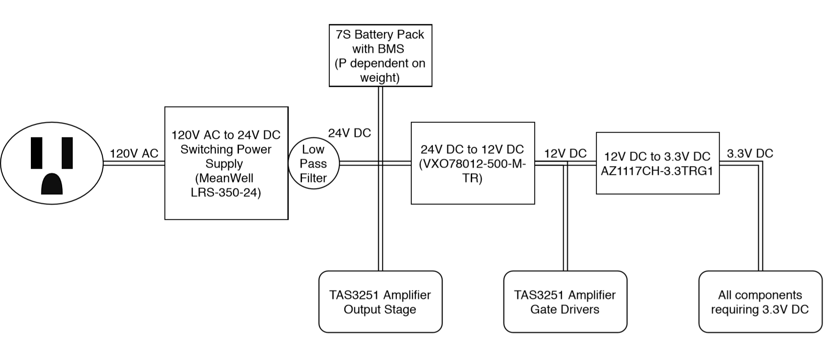
Figure 2. Power supply Schematic
Finally, in order to get the audio system to turn on and operate, the amplifier had registers that needed to be initialized in order for the amp to work. The group achieved this through I2C communications from the MBED which powered up the device, waited for clock initialization, and lastly wrote to all the desired registers with the appropriate values. Since the MBED was also being used as the ADC with I2S output, the code for both had to be organized and set up to be isolated as individual functions that are called as needed. Additionally, when the Bluetooth connection was added, the startup routines were ported over to the MSP432 LaunchPad.

Design Approach and Details

4.1 Design Approach
The first decision that was made was that the entire system should be modular so that if one thing needed a new revision or failed and needed to be replaced, it would be easier and less time consuming to do. This led to the Bluetooth module and amplifier boards being developed separately but at the same time with an agreed upon audio communication standard of PCM over I2S with varying frequency and a 16-bit minimum word size.
An MBED LPC1768 was used as a host processor for the development of the amp’s setup routine as well as to output audio streams over I2S to test the digital to analog functions of the amplifier. A prototype board was fabricated using a CNC mill in order to mount the ADC and amplifier for breadboard use. This board was then utilized in a large breadboard setup that included all the necessary capacitors, resistors, and inductors to support the chips. A bench power supply and function generator were used to generate the necessary voltages and clock signals required. It was left to version two of the board to include the necessary clocking hardware since it was uncertain what the clocks would need to be at that time. The amplifier was realized to be the critical path since without it there wouldn’t be any audio at all and it was proving to be a challenge to get functioning, so most of the development and debugging was focused on the amplifier / DAC chip.
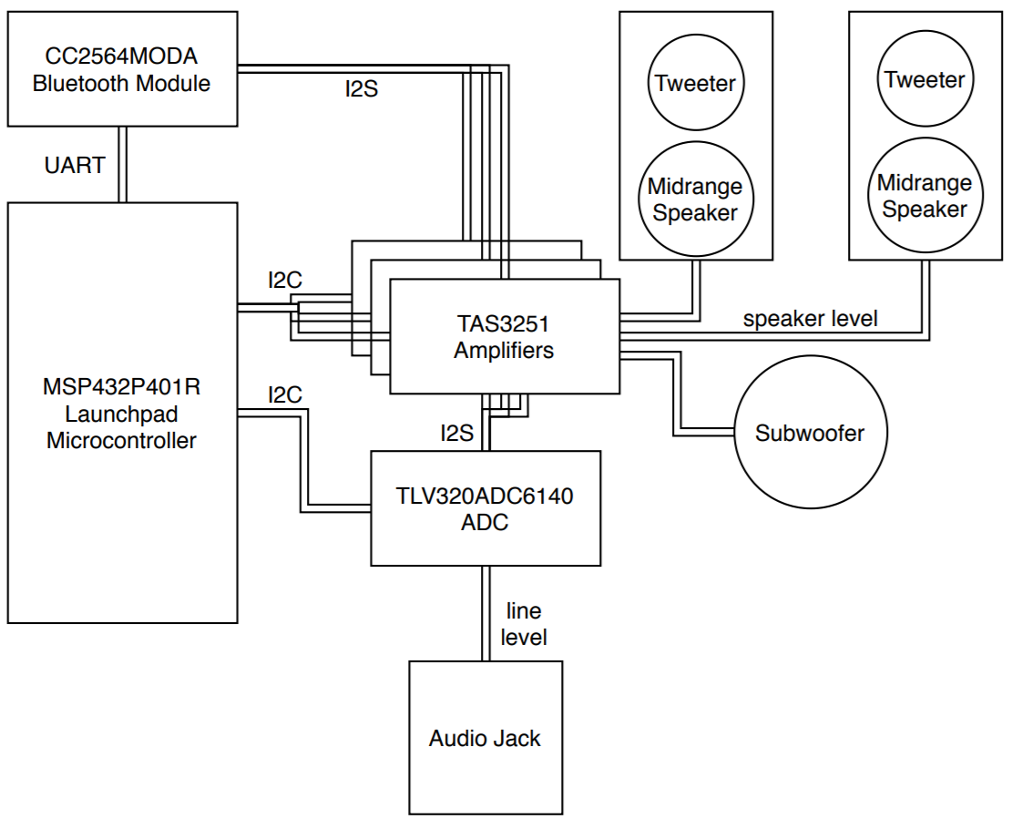
Figure 3. Block diagram of the speaker system
Several things weren’t able to be resolved, in the end. The signals coming out of the amplifier’s DAC were extremely noisy when fed data from the MBED’s ADC over I2S. When trying to isolate the problem by generating a sine wave in software instead of through the ADC, the problem wasn’t able to be replicated due to the DAC outputting garbage data consisting mostly of spikes which was indicative of a clocking error experienced earlier in the project. Clock sources for the amp were switched to the function generator from the sample clock of the I2S bus (as was standard), but although the data through the digital output of the DSP has less periods of data loss, the DAC still would output garbage data.
Several Bluetooth modules were considered, but one stood out that was specifically made for playback of audio, so it was chosen. TI also made a “booster board” for this chip, so a TI LaunchPad was used as a host processor for configuration and error reporting.
The final stage of the processing and Bluetooth was to combine the two subsystems so that the library developed on the MBED would operate on the LaunchPad since the LaunchPad could control the ADC, amp, and Bluetooth module using I2C and UART. Since the LaunchPad and Bluetooth module had separate PCBs, the amplifier and ADC would have been mounted separately to make a stack of PCBs four tall to limit the total wire lengths, and keep packaging small and compact.
The speakers for the system were chosen based on their dispersion pattern, sensitivity, required cabinet volume, weight, and cost in that order. The tweeter chosen was the Dayton Audio NHP23Ti-4 whose frequency response graph is shown in figure 3. It had a frequency response with a minimum sensitivity nearing 90 dB at 9 kHz which is the minimum allowed by the project specifications [8]. The midrange speaker chosen was the Dayton Audio RS150-4 for its smaller cabinet volume requirement while still remaining above the minimum sensitivity as shown in figure 4 [9]. The subwoofer was purchased before the start of the project since it was cheap, but its specifications also closely matched the project’s specifications [10].

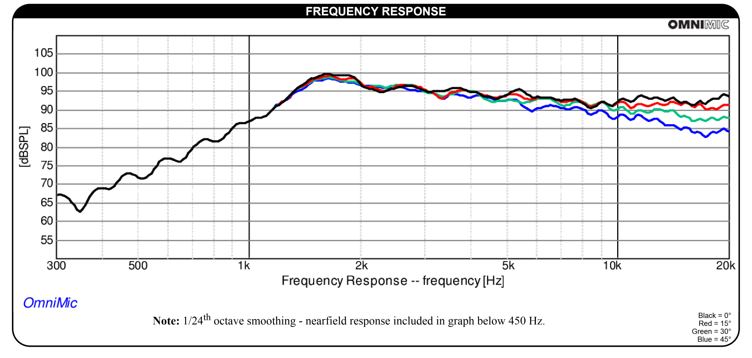
Figure 4. Frequency response of Dayton Audio NHP25Ti-4 Tweeter showing the sensitivity never going below 90dB for the operating range >2kHz (top line) [8].
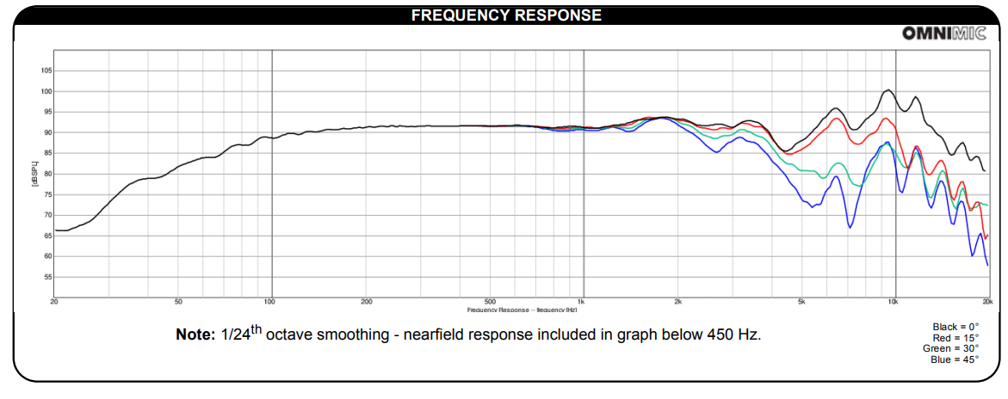
Figure 5. Frequency response of Dayton Audio RS150-4 midrange woofer showing the sensitivity never going below 90dB within the operating range of ~100Hz to ~2kHz [9].

4.2 Codes and Standards
The most significant standard that had to be adhered to was the PCM over I2S communication between the audio chips since that proved to be the most flexible standard. As such, the exact standard (bit rate, word size) had to be ironed out into something that was common in its implementation throughout the project. There were also the Bluetooth and I2C communication protocols, but those were more plug and play as compared to the I2S and didn’t pose much of an issue during the span of the project.

4.3 Constraints, Alternatives, and Tradeoffs
Many different amplifiers exist that could have done almost exactly the same thing as the amplifier that was chosen, but the chosen TAS3251 was unique in that it integrated a high power amp with a signal processor and DAC. An alternative amplifier that was considered was the TAS6424 which was a four channel amplifier that would have been enough to drive the midrange drivers and tweeters but not the subwoofer. The amount of power necessary for the subwoofer was more than a bridged TAS6424 would be able to handle, so it made sense to only learn one processor / amp instead of two even though it meant more individual amplifier chips would have to be used.
Another alternative considered was to primarily use analog signal paths instead of the digital ones. This potentially would have been much easier to diagnose since most of the signals would be exposed and could be read using an oscilloscope instead of the digital ones that required a lot of interpretation in order to understand and diagnose. The primary problem with this alternative is that the digital lines would be stacked on top of the analog lines, posing the problem of cross-talk between the clocks and communication lines to the pre-amplifier analog signals. This would create a lot of noise in the output signal from the amplifier and was determined to be too much of a risk. Thus, the signal path was kept digital.
Much of the project was scrapped since it was no longer practical to interpret the signals in a timely manner without access to most of the necessary equipment. This also included the soldering and manufacturing equipment necessary to build the enclosures and to solder various surface mount packaged components such as the ADC and processors. The prototype boards were used even though they had severe reliability issues.

Final Project Demonstration
The demonstration was difficult to do since many components ended up being fried during the debugging process when the amplifier’s heatsink was bumped and shorted several communication and power lines together causing total failure of the amplifier and suspected partial failure of the bluetooth module, but some demonstrations were done between earlier steps of the project. There were two primary modules, the bluetooth module and the amplifier module. The bluetooth module had example code that was modified to support outputting raw I2S data and was tested using an oscilloscope to read the clocking frequencies and serial data. The amplifier’s power was supplied by a benchtop power supply that measured output current and voltage while the outputs and inputs of the amplifier were measured with an oscilloscope to verify functionality. Several things were able to be demonstrated in videos available on the project website. http://ece4012y202002.ece.gatech.edu/sd20p02/
- show power consumption
- change frequency to adc and see/hear it change on output of amp
- Show bluetooth pairing and audio clock output after transmitting music

Conclusion
After the digital circuitry of the signal processor and DAC were found to be more difficult to program/setup than anticipated, it was considered whether the transition to analog should be made despite the downside of possible signal degradation. It was then decided to stick with digital since the encountered problems seemed likely to be overcome within a reasonable amount of time. In hindsight, it would have greatly simplified the debugging of the project if the processing had been switched to analog especially with limited ordering capability and debugging equipment.
The current status of the project is that the analog section of the amp works flawlessly with no perceivable distortion. However, when getting an output from the DAC successfully, most of the time the output signal is not correct. The programming of the DSP within the amp proved to be extremely difficult and was actually intended to be programmed by a GUI made by TI using their evaluation module making it impossible to be utilized. Inputting a sine wave of varying frequency into the ADC of the MBED and then outputting that onto the I2S bus resulted in a DAC output fed into the amplifier that produced a waveform where it was easy to distinguish the signal from the noise. This, however, was with a signal to noise ratio of about 8dB as measured using the FFT function of a Tektronix TDS3012B oscilloscope.
The MBED resources were difficult to debug as compared to the Bluetooth hardware that was already setup with well supported libraries, so it was decided to move to debugging the Bluetooth module instead since it’s part of the final hardware. The Bluetooth module successfully connected to audio sources, but communication between it and the amp was not established since the amplifier was fried during the debugging process. The final status of the module integration was trying to get the amplifier to successfully clock based off of the sample clock provided by the bluetooth module during audio transmission but the clock was too jittery causing the phase locked loop of the amplifier to fail to lock. If the project were to be done again, the best way to go about it would be to start with a signal processor that was better supported by TI and had more examples of its use in DIY projects like Analog Devices ADAU1701.

Leadership Roles
The leadership roles that were needed for the project were Webmaster, Expo Coordinator, Documenter, Integration Coordinator, and Coding Master. The Webmaster handled the programming and design of the website, displayed relevant information about the project including technical review papers, accepted proposal papers, and demonstration videos. The Expo Coordinator was responsible for registering for the Expo promptly before it was cancelled. The Documenter was responsible for meeting minutes and the final review of all written documents needed for the class and the project. The Integration Coordinator was responsible for establishing the compatibility and connection between the components and systems necessary for the project. Finally, the coding master was in charge of making sure all coding standards are adhered to, including the organization and functionality of the programs needed in the project.

References
[1] The New SOUNDBOKS - The Loudest Portable Bluetooth Performance Speaker, Accessed on: April, 2020. [Online]. Available: https://www.amazon.com/New-SOUNDBOKS-Bluetooth-Performance-Swappable/dp/B07WSNJ2WF/ref=sr_1_3?dchild=1&keywords=soundboks&qid=1587162459&sr=8-3&th=1
[2] Backpack for SOUNDBOKS, Accessed on: April 27, 2020. [Online]. Available: https://www.amazon.com/SOUNDBOKS-Backpack-for/dp/B07Z9FQS6Q
[3] Instructions for: The Model Twelve Transportable Component Music System by Henry Kloss, Accessed on: April 27, 2020. [Online]. Available: http://ecx.images-amazon.com/images/I/82dzuc%2B9a9L.pdf
[4] Subwoofer Plate Amps, Accessed on: April 27, 2020. [Online]. Available: https://www.daytonaudio.com/category/200/subwoofer-plate-amps
[5] MeanWell LRS-350-24 Power Supply - 350W 24V, Accessed on: April 27, 2020. [Online]. Available:
https://www.amazon.com/MeanWell-LRS-350-24-Power-Supply-350W/dp/B077B36KPB
[6] Non-Isolated DC Switching Regulator, VX078-500-M, Rev. 1.01, CUI Inc, 2020. [Online]. Available: https://www.cui.com/product/resource/vxo78-500-m.pdf
[7] L:ow Dropout Linear Regulator, AZ1117C, Rev. 4-2, Diodes Incorporated, 2019. [Online]. Available: https://www.diodes.com/assets/Datasheets/AZ1117C.pdf
[8] Titanium Dome High Power Neodymium Tweeter 4 Ohm, NHP25Ti-4, Dayton Audio. [Online]. Available: https://www.parts-express.com/pedocs/specs/275-109--dayton-audio-nhp25ti-4-specification-sheet.pdf
[9] 6" Reference Woofer 4 Ohm, RS150­4, Dayton Audio. [Online]. Available: https://www.parts-express.com/pedocs/specs/295-372-dayton-audio-rs150-4-spec-sheet-revised.pdf
[10] Thunder 5500, T5512-44, MTX Audio. [Online]. Available: https://www.mtx.com/i/mtxcom/archive/manuals/subs/TechData_T5512-44.pdf

Appendix A: QFD Diagram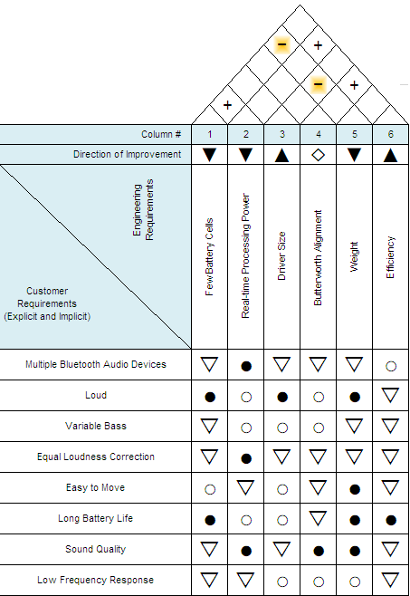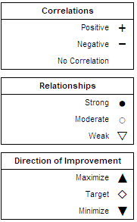

Appendix B: TAS3251 Amplifier Schematic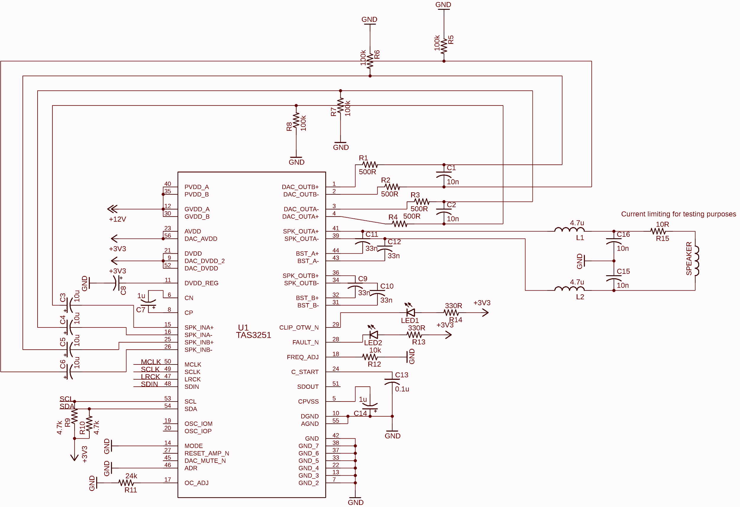

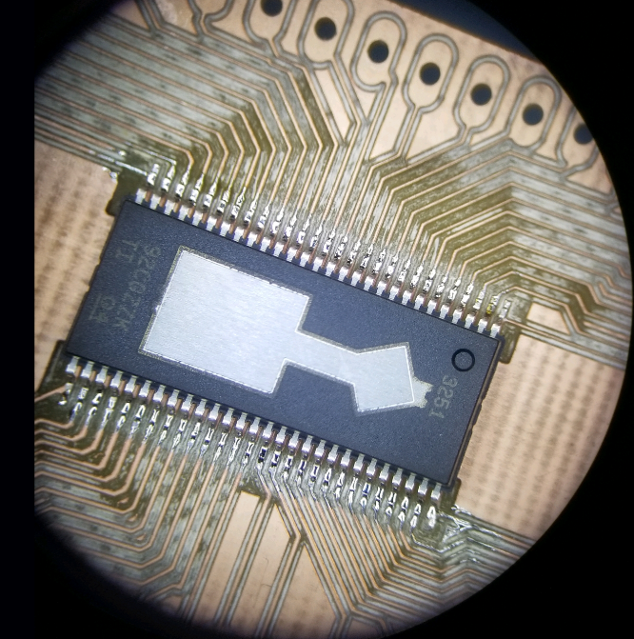
Appendix C: TAS3251 Amplifier

