**2.4 GHz Phased Array System for Lunar Extravehicular Activity (EVA) Communications**

__________________________________________________________

*ECE 4011 Senior Design Project*

Section A06, Team AN10A

Project Advisor, Dr. Greg Durgin

**Sarah Deitke** | EE | sdeitke3@gatech.edu

**Baris Volkan Gurses**  | EE | barisvolkangurses@gatech.edu

**Lucas Wray** | EE | lbwray@gatech.edu

Submitted

November 18, 2019

**Table of Contents**

**Executive Summary** ......................................................................................................... iv

**Nomenclature**..................................................................................................................... v

1.  **Introduction** .................................................................................................................. 1

1.1           Objective...................................................................................................... 1

1.2           Motivation.................................................................................................... 2

1.3           Background.................................................................................................. 2

**2.**      **Project Description and Goals.**.................................................................................. 4

2.1        Discussion of Stakeholders.............................................................................4

2.2        Customer Needs............................................................................................. 5

2.3        Design Function Performance and Metrics................................................... 5

2.4        QFD Chart .................................................................................................... 6

2.5        List of Constraints……………..................................................................... 7

**3.**      **Technical Specification** .............................................................................................. 7

**4.**      **Design Approach and Details**..................................................................................... 8

4.1        Design Concept Ideation, Constraints, Alternatives, and Tradeoffs ............. 8

4.2        Preliminary Concept Selection and Justification........................................... 9

4.3        Engineering Analyses and Experiment......................................................... 15

4.4        Codes and Standards….………………........................................................ 17

**5.**      **Schedule, Tasks, and Milestones**.............................................................................. 18

**6.**      **Project Demonstration** .............................................................................................. 18

6.1        Range Demonstration ................................................................................... 19

6.2        Coverage Demonstration .............................................................................. 20

**7.**      **Cost Analysis** .............................................................................................................. 20

**8.**      **Current Status**............................................................................................................. 22

**9.**      **Leadership Roles** ........................................................................................................ 22

**10.**  **References** ................................................................................................................... 23

**Appendix A - Task Building Blocks**................................................................................. 25

**Appendix B - Gantt Chart**................................................................................................. 27

**Appendix C - PERT Chart**................................................................................................ 30

**Executive Summary**

NASA’s nascent lunar program, Artemis, seeks to design a lander to place two astronauts on the moon; to facilitate high lander-to-astronaut data demands during moonwalks, NASA proposed a lander-mounted 2.4 GHz Wi-Fi antenna. NASA’s current-best-range-estimate for this antenna—which constrains how far astronauts can wander from the lander—is 0.5 km [1]. The AN10A team seeks to design a communications system which leverages phased arrays, outperforming NASA’s 0.5 km estimate and thus extending the radius of exploration.

Unlike conventional spacewalk antennas which radiate in all directions (such as those used on the ISS [2]), AN10A’s phased array system will send a concentrated beam of radiation towards a specific direction, with the ability to “steer” the beam to follow astronauts as they move along the lunar surface. The system will consist of three linear phased arrays—antennas in a line, each with a specific phase shift—arranged in an equilateral triangle. This arrangement allows for azimuthal (along-the-horizon) beam steering wherein each array provides coverage for 120° or 1/3 of the vicinity of the lander. A microcontroller—in conjunction with a Butler matrix phase-shifting network—will execute software, sending and receiving messages at 2.4 GHz towards targets within the azimuthal plane. The system’s beam will be able to steer in increments of 30°, with steer time on the order of nanoseconds.

AN10A’s phased array system is a novel, range-extending solution that will expand the physical boundaries of moonwalks and thus increase scientific yield. The system will be designed with a space-conscious approach, leveraging a lightweight frame, low power consumption, and collapsibility. The AN10A team will fabricate this system with an expected cost of $99.24.

**Nomenclature**

*Acronym Definition*

**ADS**  Keysight Advanced Design System

**BNC** Bayonet-Neill-Concelman Connector

**EVA** Extravehicular activity

**HFSS** High-Frequency Structure Simulator

**HLS**  Human Landing System

**IDC**  Interdisciplinary Design Commons

**IEEE**  Institute of Electrical and Electronics Engineers

**ISS** International Space Station

**LAN**  Local Area Network

**MATLAB** Matrix Laboratory

**MCU**  Microcontroller unit

**NASA**  National Aeronautics and Space Administration

**PCB**  Printed circuit board

**PERT**  Program Evaluation and Review Technique

**QFD** Quality Function Deployment

**RF**  Radio frequency

**Rx** Receiver

**Tx** Transmitter

**UHF**  Ultra-high frequency (300 MHz – 3 GHz)

**USB** Universal Serial Bus

**VHF**  Very-high frequency (30 MHz – 300 MHz)

**VNA** Vector Network Analyzer

**xEMU**  Exploration Extravehicular Mobility Unit

**2.4 GHz Phased Array System for Lunar Extravehicular Activity (EVA) Communications**

**1.    Introduction**

The AN10A team will design a lunar-lander-mounted phased array system which will be capable of communicating with moonwalkers over 0.5 km away, in any direction.  The team is requesting $99.24 to develop a prototype of the system.

**1.1** **Objective**

The team will design a novel phased array system which, when mounted on a lunar lander, will steer its beam electrically (i.e. without moving parts) at astronauts, providing highly efficient communications and exceeding NASA’s 0.5-km current-best-range-estimate [1].  The system—consisting of 2.4 GHz patch antenna arrays arranged in an equilateral triangle—would be capable of steering its beam azimuthally (i.e. anywhere along the horizon) with 30° resolution. The array will be driven by a Butler matrix feed network, which will provide the necessary phase-shifting on the array elements for a desired direction.  All beam-steering commands and signal processing will be performed by a microcontroller on a custom RF switch board. Simulations of the system in a lunar environment will be conducted to characterize its propagation characteristics. Unfortunately, the full system cannot be assembled and tested due to COVID-19.

**1.2** **Motivation**

Future moonwalkers may equip themselves with high-data-demand devices such as live-streaming high-definition video cameras and advanced suit peripherals (heads-up display, life support telemetry).  In order to meet these demands, a frequency higher than VHF—the frequency commonly used for spacewalks [2]—must be employed. While 2.4 GHz Wi-Fi provides higher data rates, it comes at the cost of over 18 dB more path loss, resulting in significantly shorter range than its VHF counterpart.  However, Wi-Fi’s limited range directly constrains the operational radius of moonwalks (relative to the lander). The AN10A team desires to develop a Wi-Fi transceiver in the form of a phased array, which will compensate for the increased path loss with higher directivity. The system will also be conscientious of the limitations imposed by spaceflight: the structure will be lightweight (consisting almost exclusively of PCBs), low-power (only two active components), small in form-factor, and the ability to be collapsed onto its mounting structure.

**1.3** **Background**

**1.3.1 Artemis Program EVA Communications System**

NASA’s latest program with lunar aspirations, the Artemis Program (2019 –), seeks to place two astronauts on the surface of the moon via the yet-undeveloped Human Landing System (HLS).  NASA’s proposed HLS communications system calls for a high-speed 2.4 GHz Wi-Fi antenna for an HLS-to-astronaut (bidirectional) link, with a current-best-estimate range of 0.5 km [1]. While AN10A’s phased array will operate at the same frequency, it will exceed this range specification while providing a low-cost, low-weight, power-efficient architecture.

**1.3.2** **Phased Arrays**

AN10A’s antenna design will utilize phased arrays, which in a broad sense provide a narrow “beam” of radiation in an arbitrary and modifiable direction.  Physically, a phased array is a group of identical antennas arranged in a pattern, all with relative phase shifts in their driving signals. The result of specifically varied antenna positions and phase shifts produces pattern interference, confining much of the antennas’ radiation towards a given direction.  Modifying the antennas’ phase shifts changes the beam direction, known as “beam steering” [3]. AN10A’s array will have elements arranged in a line, known as a linear array. The linear arrangement grants one degree of freedom for beam steering, which AN10A has chosen as the azimuthal direction.

To further increase the antenna’s directivity, the individual array elements of AN10A’s design will be vertically-stacked patch antennas.  This technique leverages the same interference phenomenon seen in arrays to confine radiation toward the horizon—however, the beam direction of each patch stack is fixed along the azimuthal plane.

**1.3.3** **Butler Matrices**

Although part of the phased array’s operation is determined by element position, each element must also have a specific phase shift for beamforming to actually take place.  AN10A’s system will perform this phase shifting using a passive feed network known as the Butler matrix. The Butler matrix is a microstrip structure with *N* inputs and *N* outputs; it facilitates beam-steering by applying specific phase-shifted signals to each element of an *N*-antenna array.  Typically, the structure is only capable of steering the beam to one of *N* positions.  A particular beam direction is chosen by applying a signal to one of *N* ports while keeping the other ports open.  Thus, each driven input port maps to a direction in space towards which the array’s beam will radiate [3].

**2.     Project Description, Customer Requirements, and Goals**

This team will design a lander-mounted antenna array capable of communicating with Astronaut xEMU suits. This system will consist of three patch antenna array boards arranged in a triangle. The array boards will be custom-designed and fabricated, with soldered-on BNC connectors; a microcontroller relay a signal to the arrays to demonstrate transmission. The three array boards will be connected by metal hinges to form a connected ground. AN10A aims to design its system with greater than 0.5 km range performance.

**2.1 Discussion of Stakeholders**

The stakeholders of this system include NASA, US Congress, co-sponsored Mission Investigators, and US Citizens. NASA is managing the Artemis missions and will depend on reliable antenna systems. The US Congress is allocating taxpayer dollars to this NASA mission and will expect working antennas with this financial commitment. Future allocations to NASA missions will depend on the reliability of the Artemis mission components, including antenna systems. Co-sponsored Mission Investigators include universities and other researchers that have scientific instruments on the Artemis missions. These stakeholders will rely on accurate transmitting and receiving of data through our antenna system, but they do not have as large of a stake in project success as NASA or the US Congress. Finally, US Citizens are the direct contributors to funding this mission through their taxpayer dollars, but most citizens will only benefit through television streaming news coverage entertainment and indirect scientific research and development. This information is summarized below in Chart 1.

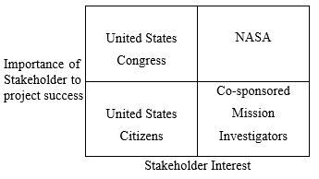

**Chart 1.** 2x2 stakeholder chart for AN10A’s phased array system

**2.2 Customer Needs**

1. This antenna system will have reliable antenna communications between lunar lander and astronauts for 0.5 km or greater range.

2. The array will easily deployable by astronauts, since astronaut time is expensive.

3. The systems manufactured target price will be $100 or less for NASA. This cost prioritizes expensive yet lightweight antenna materials, minimizing the launch cost (which depends on weight) of this system.

4. This antenna system will need to be compatible with other communications systems used by NASA.

**2.3 Design Function Performance and Metrics**

The antenna system will provide communications between astronauts and the lunar lander. Satisfactory communication will be achieved if the astronauts can maintain communications past 0.5 km. Ranges which offer no improvement include ranges between 0.3 and 0.5 km. Less than 0.3 km range for the antenna will be considered unsatisfactory design and/or implementation.

This system needs to function for the entire Artemis mission duration. Currently, this design will need to last between 8 and 21 days to be successful [4]. The system will be subjected to wear and tear from solar wind radiation and cosmic ray bombardment. If the antenna maintains transmission power from the same input power over 21 days in space, that will be considered excellent design. If the antenna loses <10% of transmission power over the course of 21 days, this will be acceptable design. If the antenna loses >10% of transmission power over the course of 21 days, this will be considered a failure in design.

**2.4 QFD Chart**

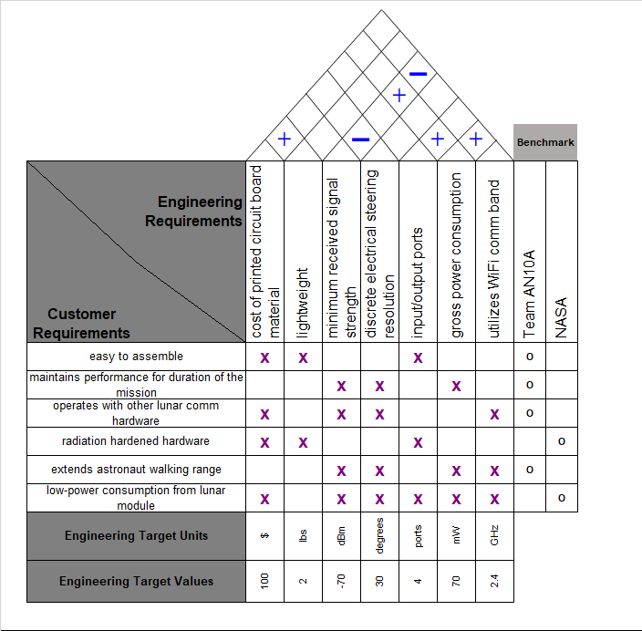

**Figure 1.** QFD chart for team AN10A’s phased array antenna system

**2.5 List of Constraints**

1. This antenna system needs to be able to communicate over the standard IEEE 802.11 LAN 2.4 GHz frequency to be compatible with other communications systems in the xEMU suits.

2. The array PCB boards are constrained to 2 lbs. of overall weight to minimize launch cost.

3. This product will have to function in space; thus, the final product will need to be “radiation hardened” to protect it from cosmic ray bombardment and solar radiation.

**3.** **Technical Specifications**

|  |  |
| --- | --- |
| **Feature** | **Specification** |
| System Azimuthal Steering Resolution | 30° |
| Single Array Azimuthal Coverage | 120° |
| Single Array Patch Antenna Count | 4 x 4 antennas |
| 0.5-Kilometer Signal Strength | -70 dBm |
| System Minimum Received Signal Strength | -70 dBm |
| 3 dB Bandwidth | 20 MHz |

**Table 1.**  Phased array specifications

|  |  |
| --- | --- |
| **Feature** | **Specification** |
| Single Butler Matrix I/O Ports | 4 |
| RF Switch Chip Minimum State Count | 12 |
| MCU Minimum Sample Rate | 5 GS/s [6] |
| Supply Voltages | 3.3 / 5 VDC |
| Wi-Fi Module Tx Power Consumption | 63 mW [5] |
| MCU Power Consumption | 0.36 mW [6] |

**Table 2.**  Front/back-end specifications

**4.** **Design Approach and Details**

**4.1 Design Concept Ideation, Constraints, Alternatives, and Tradeoffs**

The primary goal of this project is to design a transceiver that can transfer data to a separate off-the-shelf transceiver with a gain comparable to astronaut EVA communication devices over 0.5 km away. The communication link between the designed transceiver and off-the-shelf transceiver needs to be stable. Since the designed transceiver will be deployed on lunar modules, it needs to withstand extremely low and high temperatures and ionizing radiation present in the space environment. Furthermore, it needs to be compact, low-cost, lightweight, and low-power. Most importantly, it needs to have a high enough gain in the azimuthal direction such that it exceeds the 0.5 km range goal specified by NASA for the Artemis missions.

Conventional single antenna transceivers do not provide high enough gain to satisfy the range specification. Therefore, an unconventional approach is needed. Phased arrays provide one solution as they have significantly-higher gain than single antenna transceivers. By utilizing multiple antenna elements, phased arrays radiate multiple beams that constructively interfere and allow the main lobe to be spatially reconfigurable. By having multiple beams constructively interfere with each other, phased arrays provide high far-field gain. While phased arrays are hard to design and implement, they could be designed to be compact, cheap, and lightweight.

Another solution is provided by Fresnel zone plate antennas. These antennas also focus the beams so that the radiated waves constructively interfere in the far field. However, they usually consist of a single antenna with a supporting plate structure that focuses the beams. Fresnel-zone plate antennas are cheap, lightweight and simple to design, but they do not provide as much gain as phased arrays, and they are physically larger, making them harder to integrate with a lunar module [7].

Since phased arrays provide higher gain with spatial reconfigurability needed to adapt the transceiver to different propagation conditions on the moon, the phased array was chosen as the solution to address the aforementioned challenge. The specific system components and component-level design tradeoffs will be outlined in the next section.

**4.2 Preliminary Concept Selection and Justification**

**4.2.1** **System Overview**

The proposed phased array system will consist of a front end and a back end. The front end will be comprised of three identical antenna arrays and passive feeding networks in the form of Butler matrices. These identical elements will be fabricated on three boards and connected together to form an equilateral triangle. The back end will be comprised of RF switches, a Wi-Fi module and an MCU for signal processing and system control. The system-level architecture is shown in Figure 2.

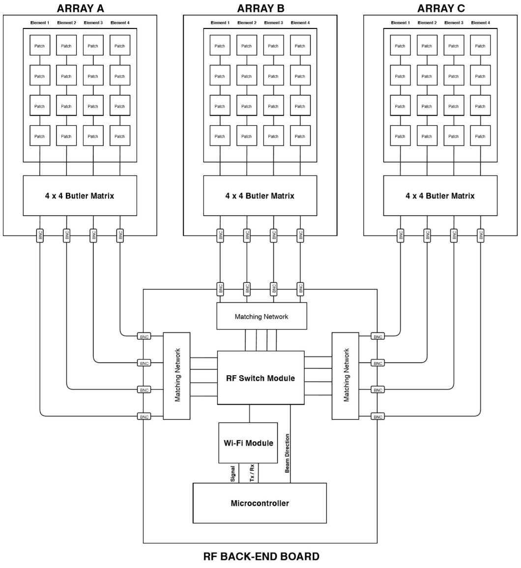

**Figure 2.** System-level architecture for the proposed phased array system

**4.2.2** **Antennas**

The antenna array will be a linear array with microstrip patch antenna elements. Patch antennas are selected as the array elements due to their compact size, scalability, and straightforward implementation on PCBs. Compared to dipole antennas, for instance, patch antennas provide 3 dB more gain due to the radiated power being concentrated in a hemisphere rather than a sphere as would be the case for dipoles. Furthermore, patch antennas are fabricated on PCBs, allowing the antenna array and the feeding network to be fabricated on the same board.

Due to patch antennas’ radiating into a hemisphere, a single patch antenna array would not cover the entire azimuthal plane that is required for lunar communications. However, this issue is easily solved by utilizing three identical arrays placed 120-degrees apart from each other, allowing 360-degree coverage. Patch antennas also radiate in the vertical direction, and this radiation reduces the gain in the azimuthal plane. Since the azimuthal range needs to be maximized, azimuthal gain could be further increased by cascading (“stacking”) the patch antennas as shown in Figure 3.

Each individual patch antenna should be optimized for 2.4 GHz. While an impedance matching network is not required between patch antennas, a matching network will be implemented on the first patch via inset feeding.

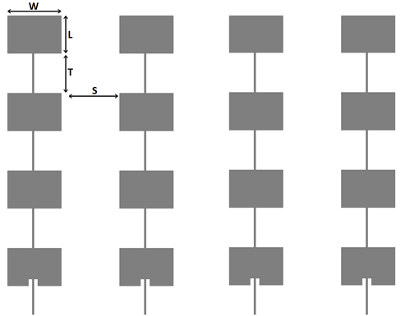

**Figure 3.** 4x4 linear antenna array comprised of stacked microstrip patch antennas

**4.2.3** **Feeding Network**

Power consumption, cost and design simplicity are major considerations for the feeding network since the system will be deployed on a lunar module. Passive feeding networks are superior to active feeding networks with respect to these considerations since passive networks do not use any active components. Although a microcontroller is needed to steer the beams in a passive network, the power consumption is substantially lower than that of active networks. The cost is also significantly lower, since active components such as phase shifters cost more than simple microstrip transmission lines used to implement passive components. Furthermore, due to their passive nature, passive networks are robust to electrostatic discharges and ionizing radiation, a key design requirement for the phased array system.

On the other hand, passive networks take up more space and do not allow for continuous beam steering. Passive networks steer the beam by selecting which port to excite. For instance, for a 4-port array, if port 1 is excited, the main lobe would be directed towards +22.5 degrees in the azimuthal plane. If port 2 is excited, the main lobe would be directed towards +67.5 degrees and so on. However, these disadvantages are outweighed by the aforementioned advantages especially due to the application and environment that the proposed phased array system will be used in.

Between types of passive feeding networks, Butler matrices were chosen to form and steer the beams since they provide an easy-to-implement topology with fewer degrees of freedom. An example Butler matrix topology for a 4-port array is shown in Figure 4. An alternative to the Butler matrix is the Rotman lens, which is an electromagnetic structure in the shape of a star that acts as a waveguide and phase shifts incoming signals by directing them to specific propagation paths. While Rotman lenses are more compact, they pose significant challenges in implementation and debugging.

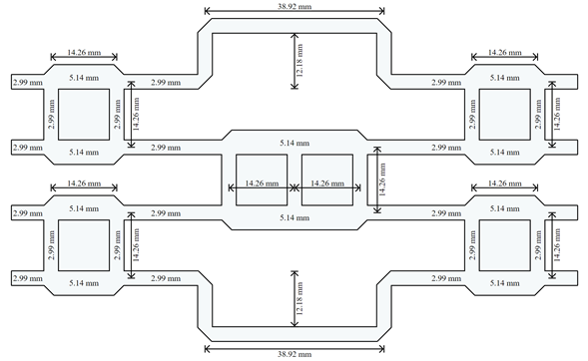

**Figure 4.** Butler matrix topology and dimensions for a 4x4 phased array operating at 2.4 GHz Source: Adapted from [14]

Both the antenna array and its Butler matrix will be implemented on the same board to simplify the fabrication and deployment. Design and fabrication of the front end that hosts the antenna arrays and Butler matrices is a critical path item as shown in the PERT chart in Appendix C. Therefore, careful consideration will be given to ensure that there are no errors made during the process. If there are unforeseen circuit errors or layout errors on the board, it will be debugged, redesigned and refabricated rapidly to ensure that the tasks on the timeline shown in Appendix A are completed by their deadlines.

**4.2.4** **Back end**

The back end will be implemented on a separate PCB and will consist of a 2.4 GHz Wi-Fi module, RF switches, and an MCU. The off-the-shelf Wi-Fi module will be responsible for signal processing and analog-to-digital conversion. For *N* ports in each antenna array, there will be *N* RF switches. RF switches will select which port will be excited and whether that port will be used for signal transmission or reception. Both the RF switches and the Wi-Fi module will be connected to the MCU, which will control the system.

Design and fabrication of the back end is also a critical path item that needs to be carefully undertaken with the same contingency plans mentioned in the previous section.

**4.2.5** **Mechanical Fixture and Connections**

The three boards that will host the antenna array and the feeding network will be connected to each other side to side with metal hinges as shown in Figure 5. This will allow the front end to be deployable by having it folded when the phased array is not in use and having it unfolded as a triangle when the phased array is in use. Furthermore, the metal hinges will be multi-functional as they will also be used to ground the system. This will be achieved by having the hinges connect to the board’s ground plane with vias. Utilizing the metal hinges as connections to the ground will enable more robust and stable connection to the ground. Having a stable ground connection is critical for minimizing the noise that would be directly coupled to the board components, a critical requirement for improving the range. The back-end board will either be cut as a triangle to be connected to the other three boards with hinges or will be placed away from the front end.

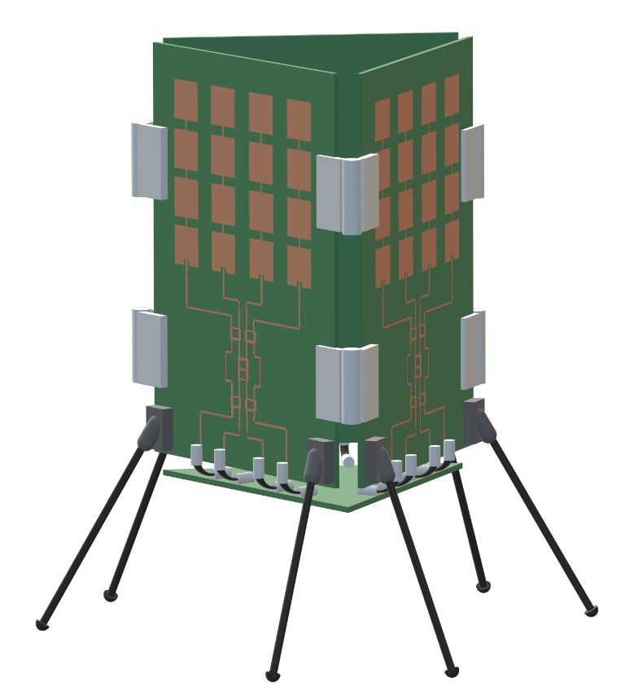

**Figure 5.** 3D model of system, showing arrangement of array panels and back-end board

         Signals will be driven from one board to another via coaxial cables and coaxial cable connectors. The connections between the Wi-Fi module and the MCU will be made via jumper cables. For demonstration purposes, connections from the power supply to the system will also be made via jumper cables. However, this connection will most likely change when the system is integrated to a lunar module. Due to COVID-19, the system can not be assembled and tested. The final demonstration will consist of the simulated design.

**4.3** **Engineering Analyses and Experiment**

In order to validate that each component is functional after it is built, various validation tests will be utilized. These validation tests are divided into two as front-end validation, back-end validation, and system validation.

**4.3.1** **Front-End Validation**

After each front-end board is fabricated, its ports will be connected to a VNA and its scattering parameters will be measured. S11 parameter of each port will be validated to be lower than -10 dB over the 20 MHz bandwidth of the 2.4 GHz Wi-Fi specified by IEEE 802.11 standards [8].

**4.3.1** **Back-End Validation**

After the back-end board is fabricated, output ports of the RF switches will be connected to a VNA and the scattering parameters will again be measured. S11 parameter of each port will be validated to be lower than -10 dB over the 20 MHz bandwidth to ensure that the matching network after the RF switches is functional.

Then, the mounted MCU will be connected to an external computer and tested to ensure that the back-end could be controlled by a computer. The software package provided by the MCU will be utilized to switch every output port on and off. This will ensure that each antenna stack could be turned on and off by the back end. Lastly, the Wi-Fi module will be triggered to turn the Rx and Tx paths on and off to ensure that the back end can switch between reception and transmission modes. Due to COVID-19, the back end board will not be delivered in time to complete the back-end validation.

**4.3.1** **System Validation**

After the aforementioned validation tests are completed, the entire system will be assembled by connecting the front-end and back-end boards as shown in Figure 5. The back end will be connected to the external computer. An off-the-shelf receiver will be placed some distance away from the phased array and will be connected to another computer. Then, a file from the phased array’s computer will be sent wirelessly to the off-the-shelf receiver’s computer. If the data transfer is successful, the system will be validated to be operational. This test will also be repeated for different distances and propagation environments to ensure that the system is robust to environment changes. Due to COVID-19, the entire system can not be assembled to complete physical validation.

**4.4 Codes and Standards**

Since the phased array system will operate at 2.4 GHz, LAN protocol set by the IEEE for that frequency, namely IEEE 802.11, will be used for the back-end design. The only component whose design will be affected by this standard will be the Wi-Fi module. A Wi-Fi module that satisfies this protocol will need to be purchased and mounted on the board. Inner workings of this protocol will be abstracted away by the chip. [8]

The microcontroller will be connected to an external computer with USB. The USB connection will provide 480 Mbps high-speed data rate and supply 5 V power to the MCU [9].

All of the components purchased for the system also need to be certified for space applications following EEE-INST-001 and EEE-INST-002 standards specified by NASA. Components that follow these standards are usually specified by the component distributors. Therefore, off-the-shelf components with these specifications will be targeted. [10]

**5.** **Schedule, Tasks, and Milestones**

The specific task building blocks, team responsibility, and relative risk levels are detailed through the chart in Appendix A. An overall project timeline is provided in the form of a Gantt chart (Appendix B), and a PERT chart (Appendix C). The degree of difficulty for each task is proportional to the amount of time allocated to complete the task.

As seen on PERT chart (Appendix C), the critical path for this project is 1.2-2.2-1.4-3.1-4.1-4.2-5.2-5.3-5.4. The computations shown below illustrate the probability that AN10A will complete the project one week before the GT Capstone Expo is 78.2%.

P(T<25) = 78.2%

$$t_{e}= \frac{t_{o}+{4(t}_{m})+ t_{p}}{6}=23.75 weeks$$

$σ={(σ_{1}^{2}+σ_{2}^{2}+…+σ_{n}^{2})}^{1/2}=1.59 weeks$

$$Z_{s}= \frac{25-23.75}{1.59}= 0.786 = 78.2\%$$

**6.** **Project Demonstration**

To prove that the system can maintain a stable 2.4 GHz communication link to a transceiver placed at least 0.5 km away on the lunar surface, lunar propagation conditions will be modeled as close to reality as possible. Since large man-made structures introduce nonidealities, the system will be demonstrated on an empty field such as Piedmont Park. At this location, two separate demonstrations will be made.

**6.1** **Range Demonstration**

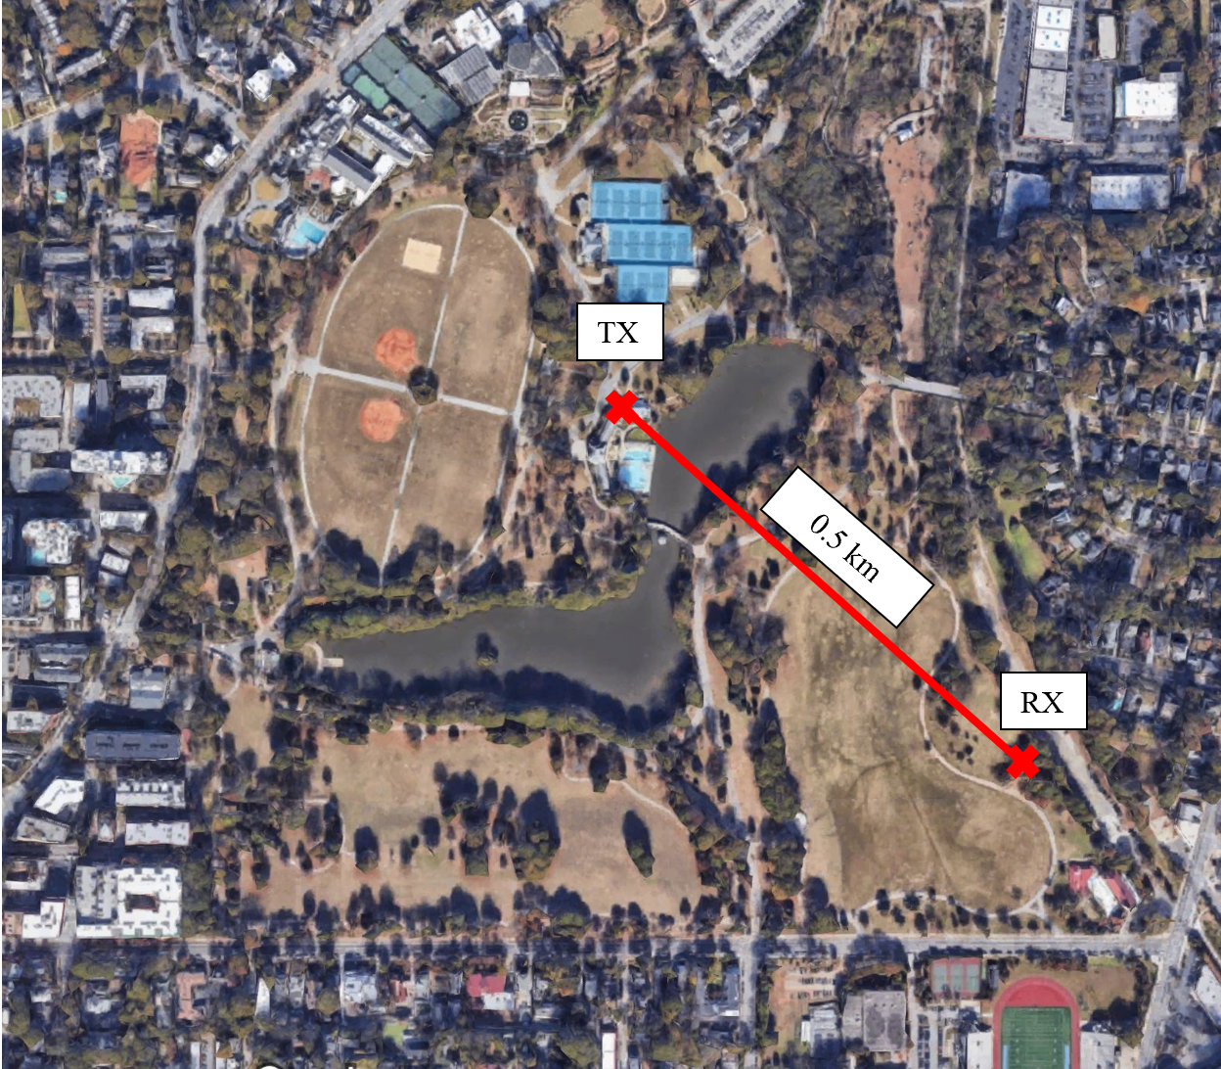 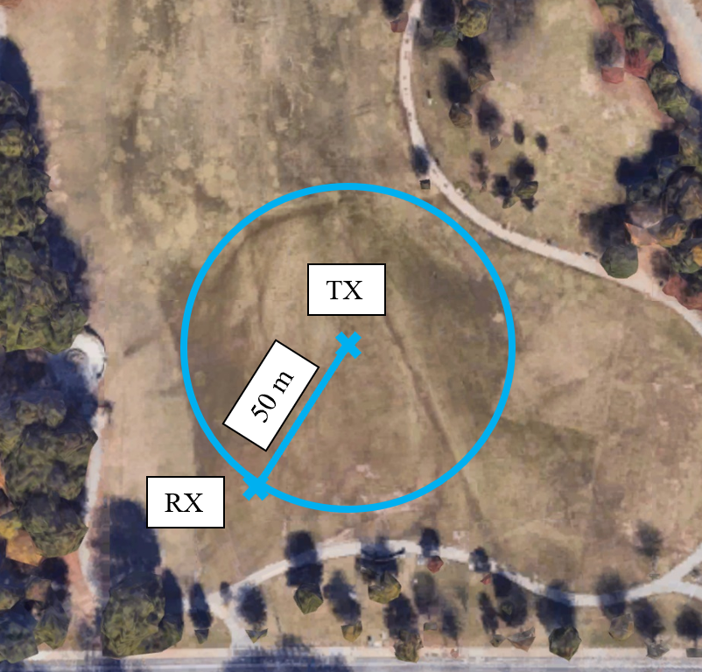

**Figure 6.** Maps of Piedmont Park, showing Tx/Rx placements for range (left) and coverage (right) demonstrations

First, the phased array system and an off-the-shelf transmitter with an isotropic gain of 17 dBm will be placed 0.5 km away from each other as shown in Figure 6. Then, the phased array will ping the transceiver to determine if a successful link is made. This will be further demonstrated by transferring a file from the phased array to the transceiver and back. If the setup passes these tests, a successful link will be confirmed.

This demonstration process will be repeated by moving the transceiver away from the phased array in 100-m intervals until the link is lost. The distance at which the link is lost will be recorded as the azimuthal range. To determine the maximum range on the lunar surface, losses from the lunar propagation simulation will be superimposed onto the measured data, and lunar surface range will be calculated. Due to COVID-19, project demonstration will be completed with simulation only.

**6.2** **Coverage Demonstration**

After the azimuthal range is determined experimentally, the transceiver will be moved around the phased array in a circle with a radius of 50 m as shown in Figure 6. At each location, the same procedures to confirm if a successful link is made will be repeated. If a successful link is maintained at all locations, the phased array will be determined to cover the entire azimuthal plane. Due to COVID-19, project demonstration will be completed with simulation only.

**7. Cost Analysis**

AN10A’s project will consist of developing a phased array antenna system. The parts necessary for a prototype of the antenna system are listed with prices in Table 3. The cost of connectors, cables, packaging, and mechanical fixture materials are estimated. However, the connectors, cables, and packaging will be procured for free from the Senior Design Lab. Likewise, the printed circuit boards will be acquired for free due to student access to the Interdisciplinary Design Commons (IDC).

|  |  |  |
| --- | --- | --- |
| **Item** | **Unsubsidized Cost** | **Cost Minus Subsidies** |
| 4 PCBs | $123 [11] | $0.00 |
| 6 Wi-Fi/MCU modules | $84.24 [12] | $84.24 |
| Mechanical Fixture Materials | $15.00 | $15.00 |
| Connectors, Cables, and Packaging | $10.00 | $0.00 |
| **Total** | **$232.24** | **$99.24** |

**Table 3.** Prototype part costs

The development of this system relies on simulation on ADS, MATLAB, and HFSS. Since these licenses are provided to students free of charge, it will not be factored into development costs. Total labor hours per engineer on team AN10A (three engineers total) are outlined in Table 4.

|  |  |
| --- | --- |
| **Task** | **Hours** |
| Research | 15 |
| Simulation | 12 |
| Fabrication | 10 |
| Assembly | 5 |
| Testing | 10 |
| Documentation | 5 |
| **Total** | **57** |

**Table 4.** Development hours per engineer

The estimated cost of hourly labor based on a typical engineer’s starting salary is $50. For three engineers, the total labor cost is $8,550. Fringe benefits are estimated to be 30% of total labor costs, and overhead is estimated to cost 120% of labor, material costs, and fringe benefits.

|  |  |
| --- | --- |
| **Development Component** | **Cost** |
| Parts | $99.24 |
| Labor | $8,550 |
| Fringe Benefits, % of Labor | $2,565 |
| Subtotal | $11,214.24 |
| Overhead, % of Matl, Labor, & Fringe | $13,457.09 |
| **Total** | **$24,671.33** |

**Table 5.** Total development costs

This product is not designed to be sold on the public market, but rather to be a sub-system for a single NASA mission. Thus, rather than electing to set a selling price, a suggested government contract value is more appropriate. To be competitive as a contractor company in submitting a government bid, it is estimated that the markup for this type of product is around 7% [13]. Therefore, the government contract bid for $26,398.32 should be submitted for this product.

**8. Current Status**

The initial high-level design of the phased array antenna system and feeding network are completed. This represents around five weeks of work towards the project. The project proposal is complete. This work was done in parallel with the design, so it does not represent any greater percentage towards completing the final task. Sarah has completed the sub-task of the Interdisciplinary Design Common’s PCB fabrication certification, progressing towards six weeks of completed work. Six weeks in a 23.75-week project indicates that team AN10A’s project is 25.3% complete.

**9. Leadership Roles**

Baris Volkan Gurses will lead the feed network system (design and simulation) and will be Expo Coordinator. Lucas Wray will lead the antenna design system and PCB layout. He will also be Documentation Coordinator. Sarah Deitke will lead antenna and propagation environment simulation as well as PCB fabrication. Additionally, she will be the Webmaster.

**10. References**

[1] Nat. Aeronautics and Space Admin., Human Exploration and Operations Mission Directorate. (2019, Aug. 19). *Human Landing System 2024 Communication Architecture Overview*. [Online]. Available: FedBizOpps.gov/Opportunities.

[2] Nat. Aeronautics and Space Admin., *NASAFacts: Receiving Astronaut Air-To-Ground Voice Communications*. Kennedy Space Center, FL, 2006.

[3] W. Stutzman and G. Theile, *Antenna Theory and Design*, 3rd ed, John Wiley and Sons: 2013.

[4] K. Hambleton, “NASA’s First Flight With Crew Important Step on Long-term Return to the Moon, Missions to Mars,” nasa.gov. <https://www.nasa.gov/feature/nasa-s-first-flight-with-crew-important-step-on-long-term-return-to-the-moon-missions-to>. [Accessed Sep. 17, 2019]

[5] Texas Instrum., “CC3120 SimpleLink™ Wi-Fi® Wireless Network Processor, Internet-of-Things Solution for MCU Applications,” CC3120 datasheet, Feb. 2017.

[6] STMicroelectronics, “Access line ultra-low-power 32-bit MCU Arm®-based Cortex®-M0+, up to 16KB Flash, 2KB SRAM, 512B EEPROM, ADC,” STM32L011x3 datasheet, Sep. 2017.

[7] S. M. Stout-Grandy, J. S. Wight, A. Petosa, I. V. Minin, O. V. Minin, "Recent Advances in Fresnel Zone Plate Antenna Technology", Microw. Journal, vol. 51, Mar. 2008.

[8] *IEEE Standard for Information Technology,* IEEE Standard 802.11, 2016.

[9] Universal Serial Bus, “Universal Serial Bus Specification,” *USB Implementers Forum, Inc.*, 2000. [Online] Available: <http://www.usb.org>. [Accessed: Nov. 15, 2019]

[10] *Instructions for EEE Parts Selection, Screening, Qualification, and Derating,* NASA Standard EEE-INST-002, 2008.

[11] PCBWay, “PCB Instant Quote,” pcbway.com. <https://www.pcbway.com/orderonline.aspx> [Accessed Nov. 14, 2019]

[12] Texas Instrum., “SimpleLink Wi-Fi® Network Processor, Internet-of-Things Solution for MCU Applications,” ti.com. <http://www.ti.com/product/CC3120/samplebuy>. [Accessed Nov. 12, 2019]

[13] FindRFP, “What to Know When Writing a Proposal or Bid?,” findrfp.com. <https://www.findrfp.com/Government-Contracting/Proposal-Bid-Notes.aspx> [Accessed Nov. 16, 2019]

[14] Innok, Apinya & Uthansakul, Peerapong & Uthansakul, Monthippa. “Angular Beamforming Technique for MIMO Beamforming System,” *International Journal of Antennas and Propagation*, Dec. 2012.

**Appendix A - Task Building Blocks**

|  |  |  |  |  |
| --- | --- | --- | --- | --- |
| **Task Building Blocks** | **Start Date** | **End Date** | **Task Lead** | **Risk Level** |
| Design/finalize circuit topology for the feeding network | November 9th | January 6th | Baris Volkan Gurses | Medium |
| Design/finalize antenna design | November 9th | January 6th | Lucas Wray | Medium |
| Simulate the feeding network circuit on ADS | December 15th | January 6th | Baris Volkan Gurses | Medium |
| Simulate the antenna on HFSS and Simulate propagation environment on MATLAB | December 15th | January 6th | Sarah Deitke | Medium |
| Write project proposal/summary | November 9th | November 15th | All | Low |
| Create the PCB layout | January 6th | January 20th | Lucas Wray | Medium |
| Design the mechanical fixture for the system | January 6th | January 13th | All | Medium |
| Fabricate/populate the PCBs | January 20th | February 17th | Sarah Deitke | High |
| Build the mechanical fixture (cancelled due to COVID-19) | February 3rd | February 17th | All | High |
| Characterize the system | February 17th | March 3rd | All | High |
| System field tests  (cancelled due to COVID-19) | March 3rd | March 30th | All | High |
| Write final report | March 30th | April 6th | All | Low |
| Create/rehearse oral presentation | March 30th | April 6th | All | Low |
| Create the design expo demo/poster  (cancelled due to COVID-19) | April 6th | April 20th | All | Low |
| Project demonstration  (video due to COVID-19) | April 13th | April 13th | All | Medium |
| Participate in design expo  (video due to COVID-19) | April 20th | April 20th | All | Low |

**Appendix B - Gantt Chart (1/3)**

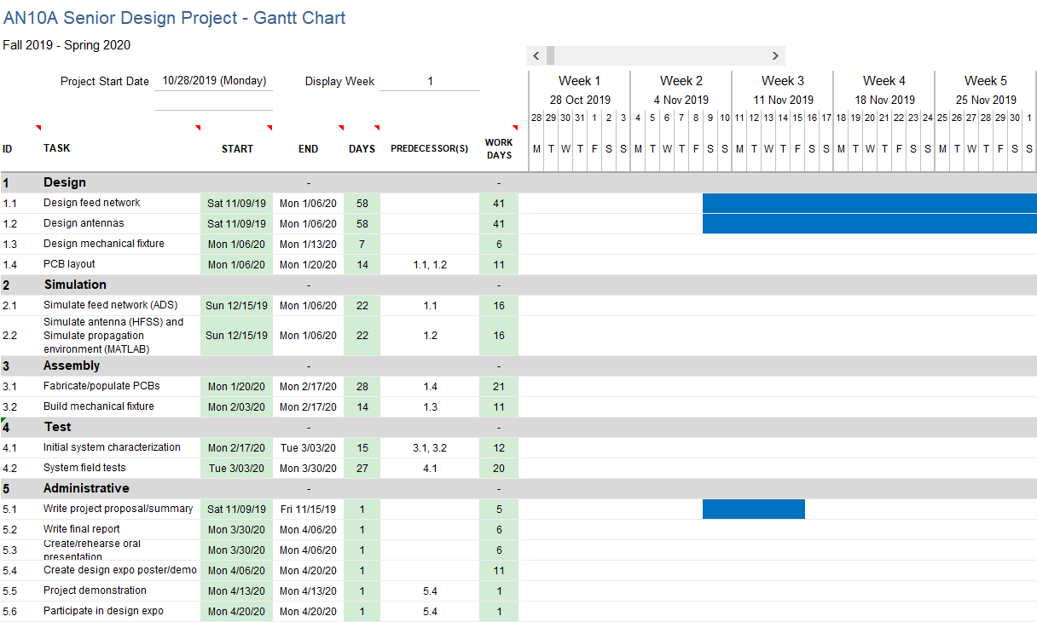

**Appendix B - Gantt Chart (2/3)**

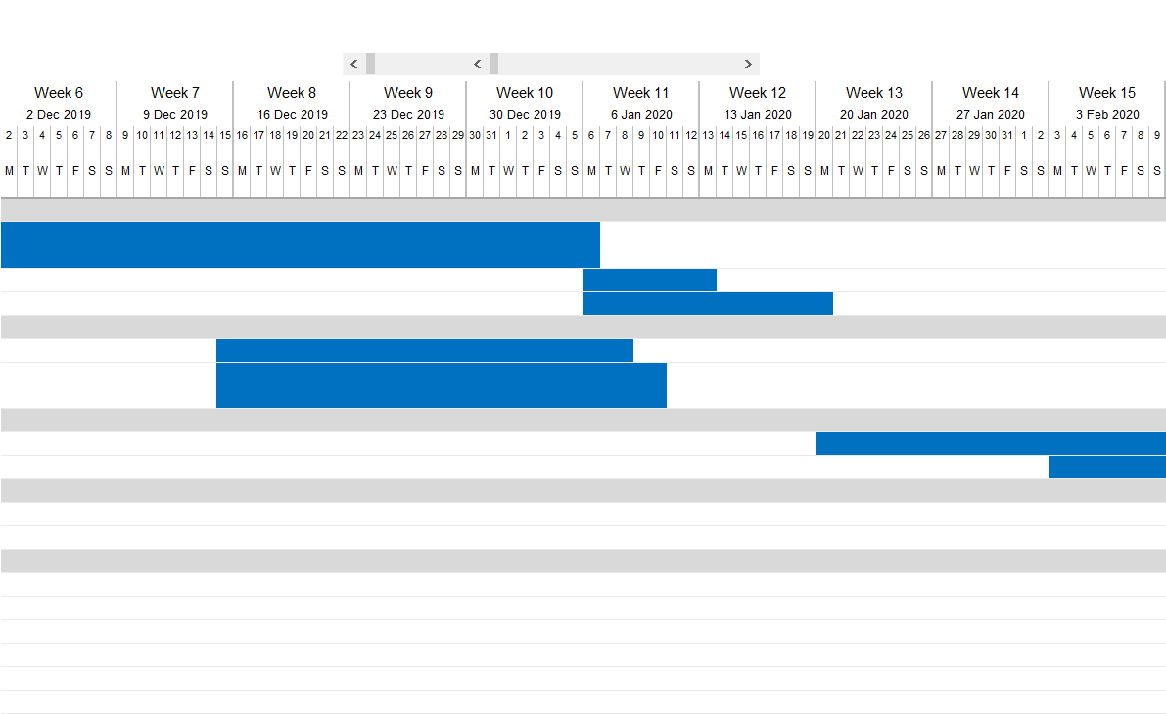

**Appendix B - Gantt Chart (3/3)**

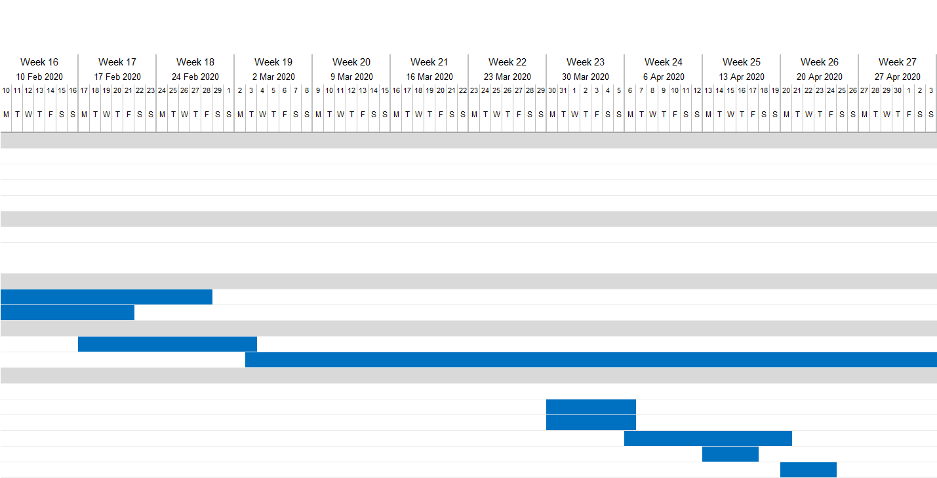

**Appendix C - PERT Chart**

Bold line represents critical path.

Format for time estimates: optimistic–expected–pessimistic (weeks).

