**2.4 GHz Phased Array System for Lunar Extravehicular Activity (EVA) Communications**

ECE4012 Senior Design Project

Section L7A, AN10A Team

Project Advisor, Dr. Durgin

Lucas Wray, lbwray@gatech.edu, Team Leader

Sarah Deitke, sdeitke3@gatech.edu

Baris Volkan Gurses, barisvolkangurses@gatech.edu

Submitted

2020 April 29

**Executive Summary**

NASA’s nascent lunar program, Artemis, seeks to design a lander to place two astronauts on the moon; to facilitate high lander-to-astronaut data demands during moonwalks, NASA proposed a lander-mounted 2.4 GHz Wi-Fi antenna. NASA’s current-best-range-estimate for this antenna—which constrains how far astronauts can wander from the lander—is 0.5 km [1]. The AN10A team designed a communications system which leverages phased arrays, outperforming NASA’s 0.5 km estimate and thus extending the radius of exploration.

Unlike conventional spacewalk antennas which radiate in all directions (such as those used on the ISS [2]), AN10A’s phased array system sends a concentrated beam of radiation towards a specific direction, with the ability to “steer” the beam to follow astronauts as they move along the lunar surface. The system consists of three linear phased arrays—antennas in a line, each with a specific phase shift—arranged in an equilateral triangle. This arrangement allows for azimuthal (along-the-horizon) beam steering wherein each array provides coverage for 120° or a third of the vicinity of the lander. A microcontroller—in conjunction with a Butler matrix phase-shifting network—is required to send and receive messages at 2.4 GHz towards targets within the azimuthal plane. The system’s beam was able to steer in increments of 30° in simulation, with steer time on the order of nanoseconds.

AN10A’s phased array system is a novel, range-extending solution that will expand the physical boundaries of moonwalks and thus increase scientific yield. The system was designed with a space-conscious approach, leveraging a lightweight frame, low power consumption, and collapsibility. The AN10A team built a partially completed prototype of this system—verifying the antenna’s resonant frequency. The team was unable to complete field testing of the complete system. The resulting cost of the prototype was $553.73.

**Table of Contents**

**Executive Summary** ii

1. **Introduction** 4
   1. Objective 4
   2. Motivation 5
   3. Background 5
2. **Project Description and Goals** 7
3. **Technical Specifications & Verification** 8
4. **Design Approach and Details** 8
   1. Design Approach 8
   2. Codes and Standards 17
   3. Constraints, Alternatives, and Tradeoffs 17
5. **Schedule, Tasks, and Milestones** 19
6. **Final Project Demonstration** 20
7. **Marketing and Cost Analysis** 20
   1. Marketing Analysis 21
   2. Cost Analysis 22
8. **Conclusion** 22
9. **Leadership Roles** 23
10. **References** 23

**Appendices**

**2.4 GHz Phased Array System for Lunar Extravehicular Activity (EVA) Communications**

**1. Introduction**

The AN10A team is requesting $553.73 of funding to develop a lunar-lander-mounted phased array system. This system can communicate with moonwalkers over 0.5 km away, in any direction, through electrical beam steering.

* 1. **Objective**

The team designed a novel phased array system which, when mounted on a lunar lander, will steer its beam electrically (i.e. without moving parts) at astronauts, providing highly efficient communications and exceeding NASA’s 0.5-km current-best-range-estimate [1]. The system—consisting of 2.4 GHz patch antenna arrays arranged in an equilateral triangle—can steer its beam azimuthally (i.e. anywhere along the horizon) with 30° resolution. The array is driven by a Butler matrix feed network, which provides the necessary phase-shifting on the array elements for a desired direction. All beam-steering commands and signal processing are performed by a microcontroller on a custom RF switch board. Simulations of the system in a lunar environment were conducted to characterize its propagation characteristics.

* 1. **Motivation**

Future moonwalkers may equip themselves with high-data-demand devices such as live-streaming high-definition video cameras and advanced suit peripherals (heads-up display, life support telemetry). In order to meet these demands, a frequency higher than VHF—the frequency commonly used for spacewalks [2]—must be employed. While 2.4 GHz Wi-Fi provides higher data rates, it comes at the cost of over 18 dB more path loss, resulting in significantly shorter range than its VHF counterpart. However, Wi-Fi’s limited range directly constrains the operational radius of moonwalks (relative to the lander). The AN10A team developed a Wi-Fi transceiver in the form of a phased array, which compensated for the increased path loss with higher directivity. The system was also conscientious of the limitations imposed by spaceflight: the structure is lightweight (consisting almost exclusively of PCBs), low-power (only two active components), small in form-factor, and has the ability to be collapsed onto its mounting structure.

* 1. **Background**

**1.3.1 Artemis Program EVA Communications System**

NASA’s latest program with lunar aspirations, the Artemis Program (2019 –), seeks to place two astronauts on the surface of the moon via the yet-undeveloped Human Landing System (HLS).  NASA’s proposed HLS communications system calls for a high-speed 2.4 GHz Wi-Fi antenna for an HLS-to-astronaut (bidirectional) link, with a current-best-estimate range of 0.5 km [1]. While AN10A’s phased array operates at the same frequency, it exceeds this range specification while providing a low-cost, low-weight, power-efficient architecture.

**1.3.2** **Phased Arrays**

AN10A’s antenna design utilized phased arrays, which in a broad sense provide a narrow “beam” of radiation in an arbitrary and modifiable direction.  Physically, a phased array is a group of identical antennas arranged in a pattern, all with relative phase shifts in their driving signals. The result of specifically varied antenna positions and phase shifts produces pattern interference, confining much of the antennas’ radiation towards a given direction.  Modifying the antennas’ phase shifts changes the beam direction, known as “beam steering” [3]. AN10A’s array has elements arranged in a line, known as a linear array. The linear arrangement grants one degree of freedom for beam steering, which AN10A has chosen as the azimuthal direction.

To further increase the antenna’s directivity, the individual array elements of AN10A’s design are series-fed patch antennas.  This technique leverages the same interference phenomenon seen in arrays to confine radiation toward the horizon—however, the beam direction of each patch stack is fixed along the azimuthal plane.

**1.3.3** **Butler Matrices**

Although part of the phased array’s operation is determined by element position, each element must also have a specific phase shift for beamforming to actually take place.  AN10A’s system performs this phase shifting using a passive feed network known as the Butler matrix. The Butler matrix is a microstrip structure with *N* inputs and *N* outputs; it facilitates beam-steering by applying specific phase-shifted signals to each element of an *N*-antenna array.  Typically, the structure is only capable of steering the beam to one of *N* positions.  A particular beam direction is chosen by applying a signal to one of *N* ports while keeping the other ports open.  Thus, each driven input port maps to a direction in space towards which the array’s beam will radiate [3].

**2. Project Description and Goals**

This team designed a lander-mounted antenna array capable of communicating with Astronaut xEMU suits. This system consisted of three patch antenna array boards arranged in a triangle. The array boards were custom-designed and fabricated, with soldered-on BNC connectors. A custom-designed back-end board was fabricated to relay a signal between a microcontroller and the arrays to demonstrate transmission. Complete assembly of the three array boards with the back-end board and microcontroller was not finalized and tested due to the school closure. AN10A’s design simulation shows the system has greater than 0.5 km range performance on the lunar surface.

The primary goal of this project was to extend astronaut walking distance on the lunar surface from the lander. The final product produces a communications link greater than 0.5 km on the lunar surface while making it easy for the astronaut to communicate. Target pricing on the unit is centered around minimizing weight as rocket launch weight is the most expensive aspect of a lunar mission. Product features are highlighted below in the form of a bullet list with accompanying discussion.

* Electrical beam steering – This enables the antenna to direct radiation in the most important directions, improving astronaut range and signal.
* Lightweight – With the entire unit weighing less than two pounds, this minimizes the cost of the unit in a rocket launch.
* Foldability – The unit can be easily assembled and disassembled to stack through its metal hinges enabling the system to be easily transported without taking up much space.
* Communication frequency – This system communicates using the Wi-Fi protocol, and it can easily communicate with any piece of technology that follows this protocol.

1. **Technical Specifications & Verification**

|  |  |  |
| --- | --- | --- |
| **Feature** | **Proposed Specifications** | **Final Specifications** |
| System Azimuthal Steering Resolution | ≤ 30° | 30° |
| Single Array Azimuthal Coverage | 120° | 120° |
| Single Array Patch Antenna Count | 4 x 4 antennas | 4 x 4 antennas |
| Power Delivered to 0.5 km | -91 dBm | -80 dBm |
| 10 dB Bandwidth | 20 MHz | 17-35 MHz |

**Table 1.**  Phased array specifications

|  |  |  |
| --- | --- | --- |
| **Feature** | **Proposed Specifications** | **Final Specifications** |
| Single Butler Matrix I/O Ports | 4 | 4 |
| RF Switch Chip Minimum State Count | 12 | 12 |
| Supply Voltages | 3.3 / 5 VDC | 5 VDC |

**Table 2.**  Front/back-end specifications

1. **Design Approach and Details**
   1. **Design Approach**

**4.1.1** **System Overview**

The phased array system consists of a front end and a back end. The front end is comprised of three identical antenna arrays and passive feeding networks in the form of Butler matrices. These identical elements were fabricated on three boards and connected to form an equilateral triangle. The back end was comprised of an RF switch, a Wi-Fi module and an MCU for signal processing and system control. The system-level architecture is shown in Figure 1.

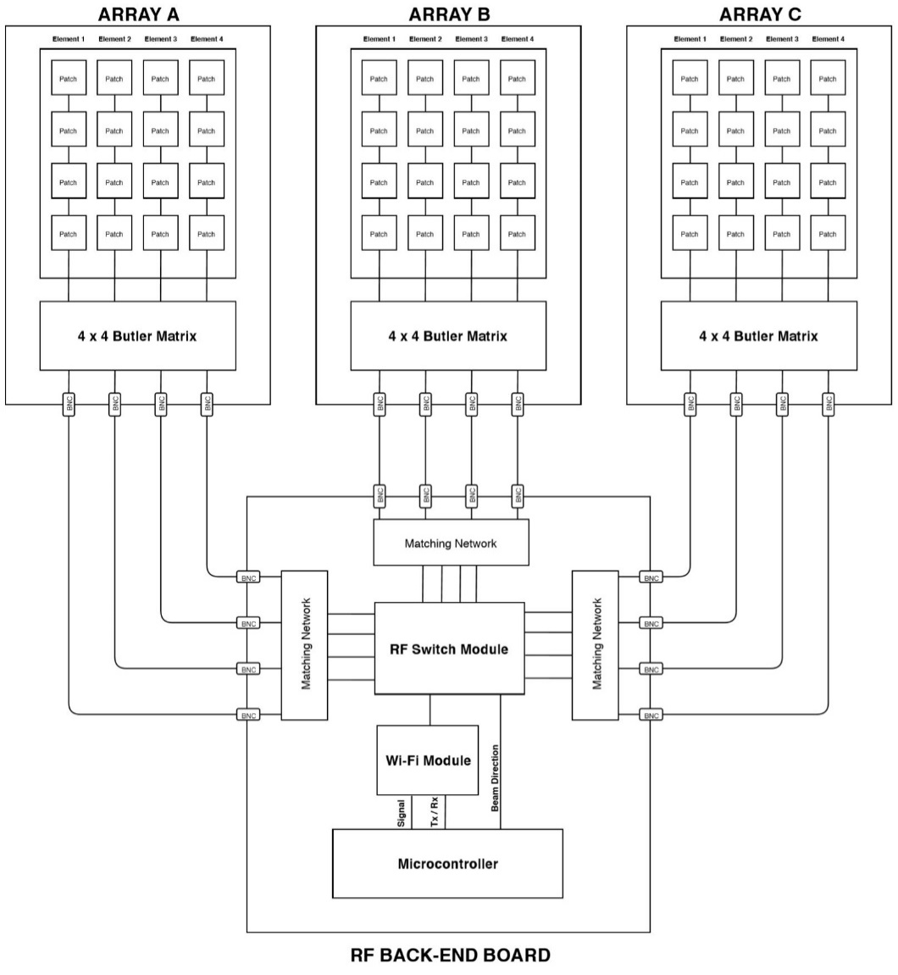

**Figure 1.** System-level architecture for the phased array system

**4.1.2** **Antennas**

The antenna array consisted of a linear array with microstrip patch antenna elements. Patch antennas were selected as the array elements due to their compact size, scalability, and straightforward implementation on PCBs. Compared to dipole antennas, for instance, patch antennas provide 3 dB more gain due to the radiated power being concentrated in a hemisphere rather than a sphere as would be the case for dipoles. Furthermore, the patch antennas were fabricated on PCBs, allowing the antenna array and the feeding network to be fabricated on the same board.

Due to patch antennas’ radiating into a hemisphere, a single patch antenna array would not cover the entire azimuthal plane that is required for lunar communications. However, this issue was easily solved by utilizing three identical arrays placed 120-degrees apart from each other, allowing 360-degree coverage. Patch antennas also radiate in the vertical direction, and this radiation reduces the gain in the azimuthal plane. Since the azimuthal range needed to be maximized, azimuthal gain was further increased by series-feeding patch antennas as shown in Figure 2.

Each individual patch antenna was optimized for 2.45 GHz. While an impedance matching network is not required between patch antennas, a matching network was implemented on the first patch via inset feeding.

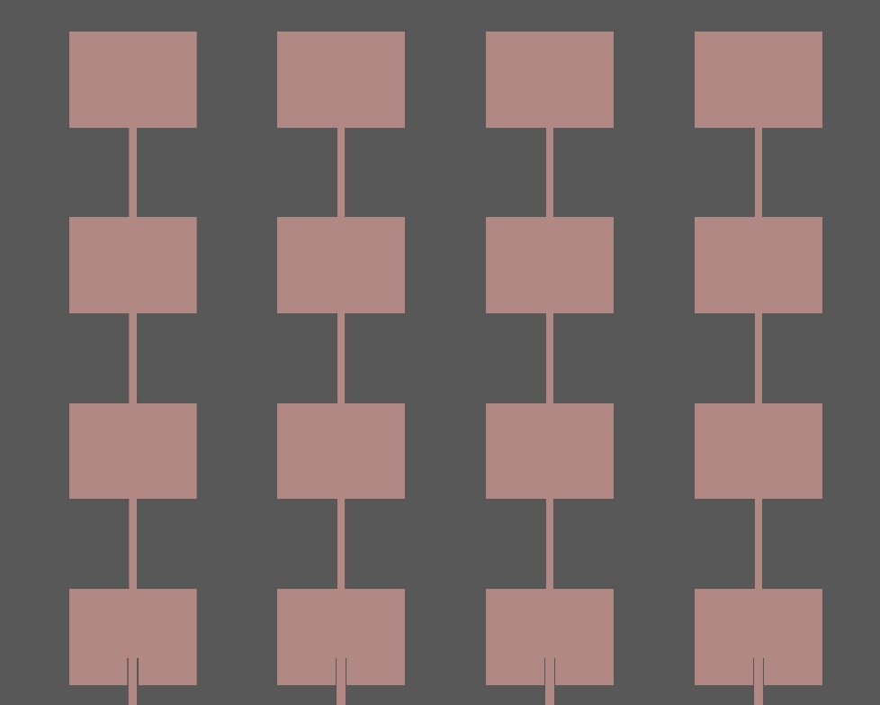

**Figure 2.** 4x4 linear antenna array comprised of series-fed microstrip patch antennas

**4.1.3** **Feeding Network**

Power consumption, cost and design simplicity were major considerations for the feeding network since the system will be deployed on a lunar module. Passive feeding networks are superior to active feeding networks with respect to these considerations since passive networks do not use any active components. Although a microcontroller was needed to steer the beams in a passive network, the power consumption was substantially lower than that of active networks. The cost was also significantly lower, since active components such as phase shifters cost more than simple microstrip transmission lines used to implement passive components. Furthermore, due to their passive nature, passive networks are robust to electrostatic discharges and ionizing radiation, a key design requirement for the phased array system.

On the other hand, passive networks take up more space and do not allow for continuous beam steering. Passive networks steer the beam by selecting which port to excite. For instance, for a 4-port array, if Port 1 is excited, the main lobe would be directed towards +22.5 degrees in the azimuthal plane. If Port 2 is excited, the main lobe would be directed towards +67.5 degrees and so on. However, these disadvantages were outweighed by the aforementioned advantages especially due to the application and environment that the phased array system will be used in.

Between types of passive feeding networks, Butler matrices were chosen to form and steer the beams since they provide an easy-to-implement topology with fewer degrees of freedom. The Butler matrix topology for a 4-port array is shown in Figure 3.

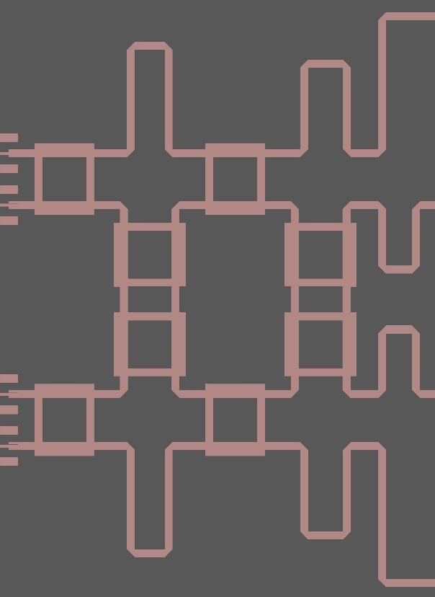

**Figure 3.** Butler matrix topology for a 4x4 phased array operating at 2.4 GHz.

Both the antenna array and its Butler matrix were designed to be implemented on the same board to simplify the fabrication and deployment. Design and fabrication of the front end that hosts the antenna arrays and Butler matrices was a critical path item as shown in the PERT chart in Appendix B. Therefore, careful consideration was given to ensure that there are no errors made during the process. Impediments to the front-end design were brought to several academic advisors to produce resolutions. Additionally, fabrication machining time was scheduled well in advance so there was no delay between the end of the design process and the beginning of the fabrication process.

**4.1.4 Front End Design Simulation**

A 3D EM model of the front end design (patch array + feeding network) was developed and simulated in ANSYS HFSS 19.2 for system characterization. Radiation patterns for the four steering angles are shown in Figure 4.

**Figure 4.** Simulated radiation patterns of the array when: a) Port 1 is excited (steered to 15°); b) Port 2 is excited (steered to -45°); c) Port 3 is excited (steered to 45°); d) Port 4 is excited (steered to -15°).

**4.1.5** **Back End Design**

The back end (Figure 5) was implemented on a separate PCB and consisted of a 2.4 GHz Wi-Fi module, RF switches, and an MCU. The Wi-Fi module chosen was the Sparkfun ESP 8266 Thing [4], which consists of a Wi-Fi module and MCU with input/output capabilities. For Butler matrix port selection, a single-pole, 12-throw RF switch is used. The switch is controlled by four digital inputs originating from the ESP 8266 board. Due to the early school closure, team AN10A did not have access to the equipment needed to assemble this PCB or to test this fabricated design.

**Figure 5.** Fabricated back end PCB for controlling electrical beam steering

**4.1.6** **Front End Design Fabrication and VNA Measurements**

Once the front end simulation results were satisfactory, Gerber files were created to fabricate the antenna boards. The front end boards were fabricated using Georgia Tech’s Interdisciplinary Design Commons’ PCB laser milling machine. One fabricated front end board can be seen in Figure 6.

**Figure 6.** Photograph of the manufactured front end board with labeled input ports

A bandsaw was used to cut the unetched edges from the RO3006 substrate, and coaxial cable connectors were soldered onto each of the ports. One front end board was then connected to a Vector Network Analyzer (VNA) to measure the S11 parameters. The S11 parameter measures how much power is reflected from the antenna. The setup for this measurement can be seen in Figure 7, and the results from this measurement can be seen in Figure 8.

**Figure 7.** Measurement setup to obtain return loss parameters for the front-end board

**Figure 8.** S11 parameters for each of the four ports on one front end board. The measurement spans from 2.4 GHz to 2.5 GHz.

**4.1.7** **Unresolved Design Aspects & Recommendations for Project**

Due to the premature school closure, AN10A did not have access to the equipment to properly assemble the designs into one overarching system. A proposed mecanical fixture for this system can be seen in Figure 9. The three boards that would host the antenna array and the feeding network can be connected to each other side to side with metal hinges. This would allow the front end to be deployable by having it folded when the phased array is not in use and having it unfolded as a triangle when the phased array is in use. Furthermore, the metal hinges would be multi-functional as they would also be used to ground the system. This would be achieved by having the hinges connect to the board’s ground plane with vias. Utilizing the metal hinges as connections to the ground would enable more robust and stable connection to the ground. Having a stable ground connection is critical for preventing unwanted radiation, a critical requirement for improving the range. The back-end board would be placed away beneath the front end. AN10A recommends proceeding with this project by taking the individual fabricated elements and assembling them into one system.

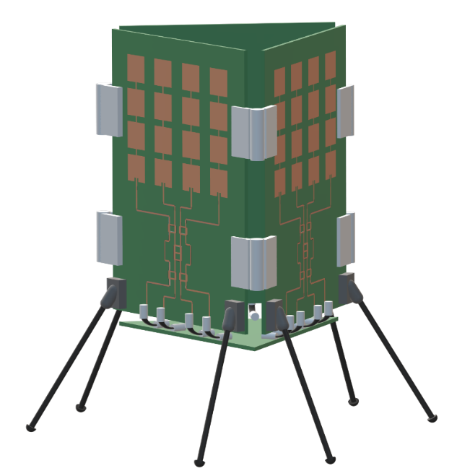

**Figure 9.** Artistic rendering of a 3D model of system, showing arrangement of array panels and back-end board.

* 1. **Codes and Standards**

Since the phased array system operates at 2.4 GHz, LAN protocol set by the IEEE for that frequency, namely IEEE 802.11, is used for the back-end design. The only component whose design is affected by this standard is the Wi-Fi module. A Wi-Fi module that satisfied this protocol was purchased to be mounted to the back-end board. Inner workings of this protocol are abstracted away by the chip. [5]

The microcontroller is designed to be connected to an external computer with USB. The USB connection provides 480 Mbps high-speed data rate and supplies 5 V power to the MCU [6].

All of the components purchased for the system also need to be certified for space applications following EEE-INST-001 and EEE-INST-002 standards specified by NASA. Components that follow these standards are usually specified by the component distributors. Therefore, off-the-shelf components with these specifications were targeted. [7]

* 1. **Constraints, Alternatives, and Tradeoffs**

The primary goal of this project was to design a transceiver that transfers data to a separate off-the-shelf transceiver with a gain comparable to astronaut EVA communication devices over 0.5 km away. The communication link between the designed transceiver and off-the-shelf transceiver needs to be stable. Since the designed transceiver will be deployed on lunar modules, it must withstand extremely low and high temperatures and ionizing radiation present in the space environment. Furthermore, it is compact, low-cost, lightweight, and low power. Most importantly, has a high enough gain in the azimuthal direction such that it exceeds the 0.5 km range goal specified by NASA for the Artemis missions.

Conventional single antenna transceivers do not provide high enough gain to satisfy the range specification. Therefore, an unconventional approach was needed. Phased arrays provided one solution as they have significantly higher gain than single antenna transceivers. By utilizing multiple antenna elements, phased arrays radiate multiple beams that constructively interfere and allow the main lobe to be spatially reconfigurable. By having multiple beams constructively interfere with each other, phased arrays provide high far-field gain. While the phased array system was hard to design, it was compact, cheap, and lightweight.

The Butler matrix was chosen to as the passive feeding network for this phased array antenna. An alternative to the Butler matrix is the Rotman lens, which is an electromagnetic structure in the shape of a star that acts as a waveguide and phase shifts incoming signals by directing them to specific propagation paths. While Rotman lenses are more compact, they pose significant challenges in implementation and debugging.

Another design alternative considered was Fresnel zone plate antennas. These antennas also focus the beams so that the radiated waves constructively interfere in the far field. However, they usually consist of a single antenna with a supporting plate structure that focuses the beams. Fresnel-zone plate antennas are cheap, lightweight and simple to design, but they do not provide as much gain as phased arrays, and they are physically larger, making them harder to integrate with a lunar module [8].

Since phased arrays provide higher gain with spatial reconfigurability needed to adapt the transceiver to different propagation conditions on the moon, the phased array was chosen as the solution to address the aforementioned challenge.

1. **Schedule, Tasks, and Milestones**

The Gantt chart for this project has been provided in Appendix A with red crosses indicating original tasks that were cancelled due to the premature school closure. For each team member, their relative contribution to the overall project is as follows: Baris Volkan Gurses led the feeding network design, integration of antenna design and feeding network design with simulation, and was the expo coordinator; Lucas Wray led the antenna design, PCB layouts for both front end and back end designs, and was the team leader/document coordinator; Sarah Deitke led the lunar propagation environment analysis, PCB fabrication, and was the web master.

For the tasks listed above, the greatest technical challenge was integrating the antenna design with the feeding network design. This was very challenging because the two designs had to be matched almost perfectly to prevent significant losses before generating a transmitting signal. The individual designs for the antenna and feeding network were the next most challenging aspects of this project as the two designs were very open ended and needed to consider size, power consumption, and weight constraints. The greatest technical risk this team experienced was attempting to fabricate and test such a large antenna system in the allotted timeline, and this risk was successful despite the abrupt school closure.

1. **Final Project Demonstration**

To demonstrate and validate the project specifications, the following items were demonstrated.

*Range Demonstration*

The purpose of this project is to improve the range of astronauts from the lunar lander on the lunar surface. Current best estimates of this range are 0.5 km [1]. Utilizing the link budget spreadsheet found in Appendix C, AN10A was able to compute a new range estimate for the proposed phased array system. The results of this computation show a new best range estimate of 0.95 km on the lunar surface assuming the highest margins of error. That range is nearly double the current best estimate and proves project validation.

*Coverage Demonstration*

Electrical beam steering is a key element of this project. After merging the antenna design with the feeding network, the front end design was simulated in ANSYS HFSS 19.2 for system characterization. The results of this simulation can be seen in Figure 4 of Section 4.1.4, and they show electrical beam steering as designed. After the front end design was fabricated, AN10A was unable to collect fabricated radiation patterns due to the school closure to validate these simulations.

1. **Marketing and Cost Analysis**
   1. **Marketing Analysis**

To sell this product, AN10A will either apply for small business funding through NASA [9] or apply for a subcontract with the company contracted to construct the lunar lander. Existing products that could be applied to this lunar communications application include dipole antennas, mechanically steered dish antennas, and cylindrical Fresnel zone plate antennas. These potential existing solutions cannot provide range estimates greater than 0.5 km on the lunar surface [1]. Our product differs because it can accomplish a lunar surface range greater than 0.5 km.

* 1. **Cost Analysis**

AN10A’s project will consist of developing a phased array antenna system. The parts necessary for a prototype of the antenna system are listed with prices in Table 3. The cost of the RO3006 substrate antennas with printing and the mechanical fixture materials are estimated. The printed antenna boards were acquired for free due to student access to the Interdisciplinary Design Commons (IDC).

|  |  |  |
| --- | --- | --- |
| **Item** | **Unsubsidized Cost** | **Cost Minus Subsidies** |
| 3 PCBs | $93.10 [10] | $93.10 |
| 3 RO3006 Substrate printed antennas | $1000 | $0.00 |
| 3 Wi-Fi/MCU modules | $50.85 [4] | $50.85 |
| Bridge USB 2.0 module | $15.50 [4] | $15.50 |
| 2 RF switches | $58.82 [11] | $58.82 |
| Mechanical Fixture Materials | $15.00 | $15.00 |
| Connectors, Cables, and Packaging |  |  |
| * 28 SMA connectors | $93.32 [12] | $93.32 |
| * 3 U. FL RCPT connectors | $3.93 [13] | $3.93 |
| * 12 SMA 18” cables | $178.89 [12] | $178.89 |
| * 2 ASSY 3.937” cables | $6.88 [12] | $6.88 |
| * 1 ASSY 9.843” cable | $13.13 [12] | $13.13 |
| * 1 USB cable | $6.97 [4] | $6.97 |
| * 1 3.7V Lithium Battery | $9.95 [4] | $9.95 |
| * Header pins | $16.13 [14-15] | $3.19 |
| * MCU practice mount | $4.20 [16] | $4.20 |
| **Total** | **$1553.73** | **$553.73** |

**Table 3.** Prototype part costs

The development of this system relies on simulation on ADS, MATLAB, and HFSS. Since these licenses are provided to students free of charge, it will not be factored into development costs. Total labor hours per engineer on team AN10A (three engineers total) are outlined in Table 4.

|  |  |
| --- | --- |
| **Task** | **Hours** |
| Research | 15 |
| Simulation | 12 |
| Fabrication | 10 |
| Assembly | 5 |
| Testing | 10 |
| Documentation | 5 |
| **Total** | **57** |

**Table 4.** Development hours per engineer

The estimated cost of hourly labor based on a typical engineer’s starting salary is $50. For three engineers, the total labor cost is $8,550. Fringe benefits are estimated to be 30% of total labor costs, and overhead is estimated to cost 120% of labor, material costs, and fringe benefits.

|  |  |
| --- | --- |
| **Development Component** | **Cost** |
| Parts | $553.73 |
| Labor | $8,550 |
| Fringe Benefits, % of Labor | $2,565 |
| Subtotal | $11,668.73 |
| Overhead, % of Matl, Labor, & Fringe | $14,002.48 |
| **Total** | **$25,671.21** |

**Table 5.** Total development costs

This product is not designed to be sold on the public market, but rather to be a sub-system for a single NASA mission. Thus, rather than electing to set a selling price, a suggested government contract value is more appropriate. To be competitive as a contractor company in submitting a government bid, it is estimated that the markup for this type of product is around 7% [17]. Therefore, the government contract bid for $27,468.19 should be submitted for this product.

1. **Conclusion**

In this work, a patch antenna array fed with Butler matrices has been demonstrated to improve the range and coverage over current lunar surface communications systems. The antenna system was designed and simulated. The front end antenna array boards and the back end RF switching board was fabricated. Due to the school closure, the entire system could not be fully assembled to complete the system level testing. If team AN10A could do anything differently, it would have been to start design earlier in order to fabricate the entire system before the school closure. The lesson learned was always plan for the worst and unexpected.

Simulation results of the front end ensure 360° coverage via electrical beam steering with 11.5 dBi maximum gain, enabling a theoretical read range of 0.95 km on the lunar surface. The next steps are assembling the system and conducting signal-to-noise ratio (SNR) measurements to empirically characterize the read range. The future of this project depends on the contemporary issue of adoption of the design by either NASA or the lunar lander contracting company.

1. **Leadership Roles**

Baris Volkan Gurses led the feed network system (design and simulation) and simulation of the assembled front end. Lucas Wray led the antenna design system and PCB layout. He was also the Documentation Coordinator. Sarah Deitke led antenna and propagation environment simulation as well as PCB fabrication. Additionally, she was the Webmaster.

1. **References**

[1] NASA, Human Exploration and Operations Mission Directorate. (2019, Aug. 19). *Human Landing System 2024 Communication Architecture Overview*. [Online]. Available: FedBizOpps.gov/Opportunities.

[2] NASA, *NASAFacts: Receiving Astronaut Air-To-Ground Voice Communications*. Kennedy Space Center, FL, 2006.

[3] W. Stutzman and G. Theile, Antenna Theory and Design, 3rd ed, John Wiley and Sons: 2013.

[4] SparkFun, “SparkFun,” sparkfun.com. https://www.sparkfun.com. [Accessed Apr. 16, 2020]

[5] *IEEE Standard for Information Technology,* IEEE Standard 802.11, 2016.

[6] Universal Serial Bus, “Universal Serial Bus Specification,” *USB Implementers Forum, Inc.*, 2000. [Online] Available: <http://www.usb.org>. [Accessed: Nov. 15, 2019]

[7] *Instructions for EEE Parts Selection, Screening, Qualification, and Derating,* NASA Standard EEE-INST-002, 2008.

[8] S. M. Stout-Grandy, J. S. Wight, A. Petosa, I. V. Minin, O. V. Minin, "Recent Advances in Fresnel Zone Plate Antenna Technology", Microw. Journal, vol. 51, Mar. 2008.

[9] NASA, “Small Business Funding Opportunities, nasa.gov. <https://www.nasa.gov/content/small-business-funding-opportunities-sbirsttr>. [Accessed Apr. 25, 2020]

[10] PCBWay, “PCB Instant Quote,” pcbway.com. https://www.pcbway.com/orderonline.aspx [Accessed

Apr. 16, 2020]

[11] Peregrine Semiconductor, “PE42512,” psemi.com. <https://www.psemi.com/products/rf-switches/pe42512>. [Accessed Apr. 25, 2020]

[12] Newark, “Cinch Connectivity Solutions,” newark.com. <https://www.newark.com/b/cinch-connectivity-solutions>. [Accessed Apr. 25, 2020]

[13] Hirose, “Electrical and Electronic Connectors,” hirose.com. <https://www.hirose.com>. [Accessed Apr. 25, 2020]

[14] Adam Tech, “Conductors, Cable Assemblies, Custom Solutions,” adam-tech.com. <https://www.adam-tech.com>. [Accessed Apr. 25, 2020]

[15] Global Connector Technology, “Innovative PCB Connector and cable assembly solutions,” gct.co. <https://www.gct.co>. [Accessed Apr. 25, 2020]

[16] Silicon Labs, “Silicon Labs,” silabs.com. <https://www.silabs.com>. [Accessed Apr. 25, 2020]

[17] FindRFP, “What to Know When Writing a Proposal or Bid?,” findrfp.com. https://www.findrfp.com/Government-Contracting/Proposal-Bid-Notes.aspx [Accessed Nov. 16, 2019]

**Appendix A - Gantt Chart (1/3)**

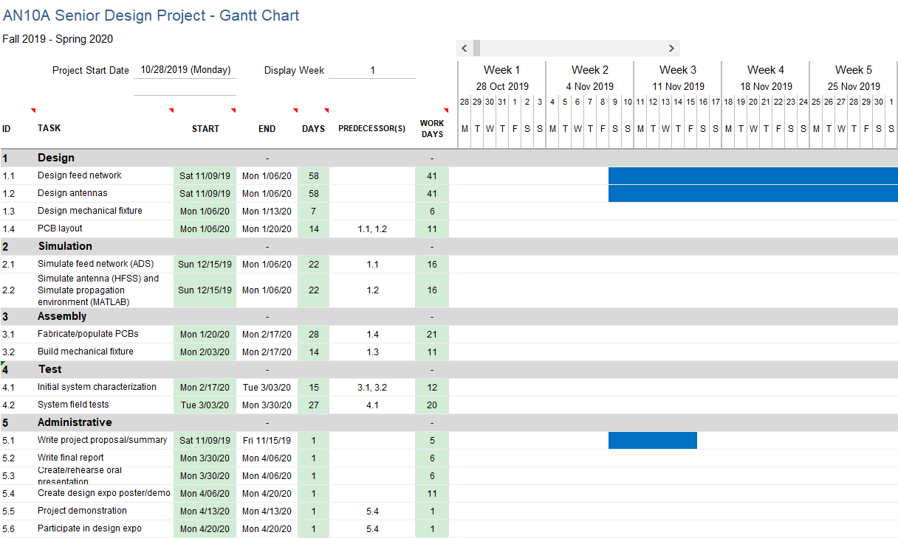

**Appendix A - Gantt Chart (2/3)**

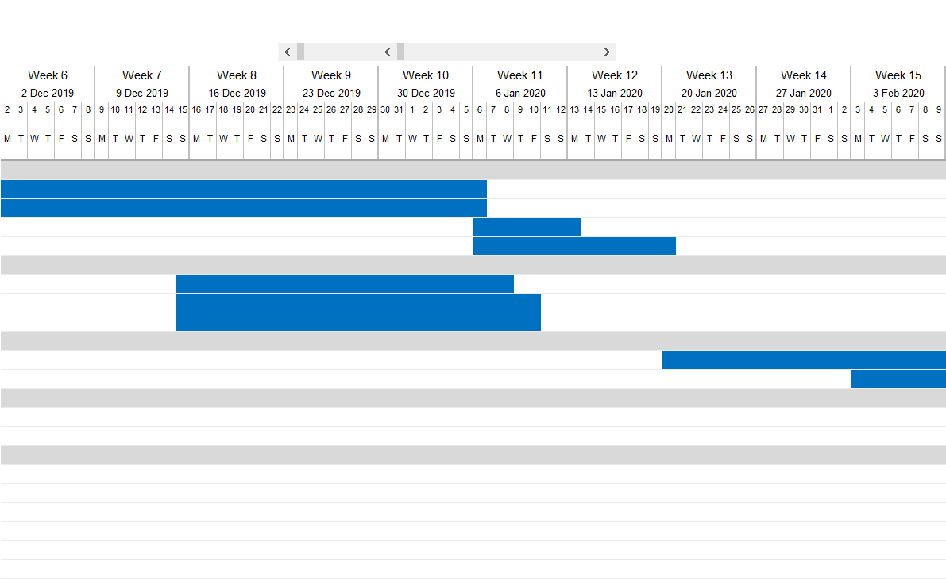

**Appendix A - Gantt Chart (3/3)**

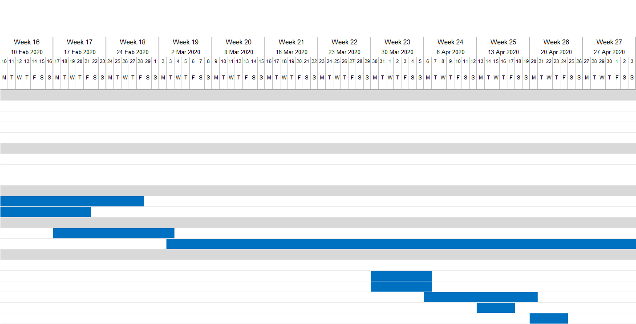

**Appendix B - PERT Chart**

Bold line represents critical path with red crosses for items that were cancelled due to the school closure.

Format for time estimates: optimistic–expected–pessimistic (weeks).

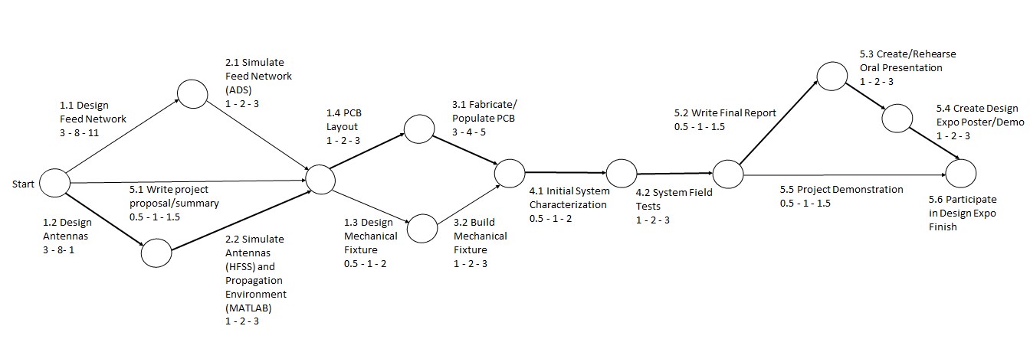

**Appendix C – Additional materials list**

* Demo poster paper submitted to 2020 IEEE RFID conference: <https://ece4012y202002.ece.gatech.edu/sd20p10/RFID_Demo_Paper.pdf>
* HFSS Front End Design file:

<https://ece4012y202002.ece.gatech.edu/sd20p10/AN10A_FrontEnd.aedt>

* Eagle Front End Design file:

<https://ece4012y202002.ece.gatech.edu/sd20p10/AN10A_FrontEnd.brd>

* Eagle Back End Design file

<https://ece4012y202002.ece.gatech.edu/sd20p10/AN10A_BackEnd.brd>

* Link Budget Calculation

<https://ece4012y202002.ece.gatech.edu/sd20p10/link_budget.xlsx>

* Bill of Materials

<https://ece4012y202002.ece.gatech.edu/sd20p10/AN10A_BOM.xlsx>